**Retail Revitalization: Improving Customer Experience For Jumpstart in the Post-Covid Era**

**Summative Assessment**



**AGUNG YUDA PRATAMA (BDSE-0922-076)**

**SOFTWARE ENGINEERING**

**LITHAN EDUCLAAS**

**(2023)**

# ABSTRACT

This paper presents a strategic plan for Jumpstart, a nationwide retail chain with 750 stores, to enhance its customer experience in response to the evolving retail landscape worsened by the COVID-19 pandemic. Jumpstart aims to transform its business model by embracing technology to offer a seamless, personalized, and engaging shopping experience. Specific objectives include enhancing customer satisfaction, increasing loyalty, driving revenue growth, and optimizing operational efficiency.

To investigate Jumpstart's customer experience, this research employs surveys and literature reviews. The findings reveal that the majority of respondents were already existing customers, visiting the stores regularly. Overall, the respondents expressed satisfaction with Jumpstart's current e-commerce platform. However, stockouts emerged as a concern, prompting some customers to switch to competitors. Consistency and user-friendliness across devices were highly valued, while website speed was considered good but had room for improvement. Product reviews played a significant role in influencing purchase decisions, and many customers were willing to pay a slightly higher price for better availability and quality.

Jumpstart's pathway to retail revitalization involves leveraging technology, enhancing product availability, ensuring consistency, and optimizing operational efficiency. These findings provide valuable insights to guide Jumpstart in achieving its objectives of enhanced customer satisfaction, increased loyalty, revenue growth, and sustainable competitiveness in the digital retail landscape.

Keywords: Retail Revitalization, Customer Experience, Post-Covid Era, E-commerce, Digital Transformation.

# ACKNOWLEDGEMENT

I would like to express my deepest gratitude to God Almighty for His blessings and guidance throughout this research. I am forever grateful for His unwavering support and divine inspiration that has led me on this journey.

I would also like to extend my heartfelt appreciation to everyone who has contributed to the successful completion of this research. I am especially grateful to my lecture, Ms. Arvinder Kaur, Lithan Lecturer, for their guidance, support, and valuable insights throughout this project.

I am also grateful to Ms. Dinda Noor Azizah, Head of English Departement from STTB, and Ms. Nupur Dongariya, Lithan Lecturer, my esteemed lecturers, for their valuable feedback and suggestions that have helped me refine my research.

I would like to thank the participants of this study for their time and willingness to share their experiences. Without their cooperation, this research would not have been possible.

Furthermore, I would like to acknowledge the contributions of the retail industry professionals who provided valuable Jumpstart input and expertise. Their insights have greatly enriched this study.

Lastly, I would like to express my appreciation to my family and friends for their unwavering support and encouragement. Their belief in me has been a constant source of motivation.

Thank you all for your invaluable contributions.

Table of Contents

ABSTRACT 2

ACKNOWLEDGEMENT 3

RESEARCH PART (PART I) 6

1. Introduction 6

1.1. Research Background 6

1.2. Research Purpose 6

2. Literature Review 8

3. Research Plan 9

3.1. Research 9

3.2. Research Philosophy (Saunders’s Onion theory) 10

3.3. Gantt Chart and Work Breakdown Structures (WBS) 13

4. Research Methodologies 14

4.1. Primary Research 14

4.2. Secondary Research 16

5. Research Approaches 20

5.1.1. Qualitative Research 20

5.1.2. Quantitative Research 21

5.1.3. Mixed Research Approach 22

6. Research Design 24

6.1. Saunders Research Onion Theory 24

6.2. Compare research methods and research approaches 25

7. Research Conduct and Analysis 28

7.1. Conduct Primary Research 28

7.2. Conduct Secondary research 39

Project Part (Part II) 44

1. Project Proposal 44

1.1. Project Objective 44

1.2. Project Scope 44

1.3. Project Constraints 45

1.4. Project Assumptions 46

1.5. Project Environment 47

1.6. Project Design 50

1.6.1. Project Flowchart 50

1.6.2. Project Wireframes 51

1.6.3. Project EERD 62

1.6.4. Project Relation Schema 62

2. Communication with Stakeholders: 63

3. Project Implementation 64

3.1. Source Code and evidence 64

3.2. Post-Implementation Survey 73

4. Reflection on Research Methods 74

4.1. Effectiveness and challenges of methods applied 74

4.2. Alternative methods to overcome the challenges: 74

5. Conclusion 76

6. Future research considerations 77

Bibliography 78

# RESEARCH PART (PART I)

## Introduction

The Paper outlines our plan to enhance the customer experience for Jumpstart, a retail chain with 750 stores nationwide. The retail landscape has evolved, and in the wake of post-COVID-19 challenges, Jumpstart aims to reshape its business model by focusing on customer experience. We aim to leverage technology to provide a seamless, personalized, and engaging shopping experience, ultimately increasing customer satisfaction, loyalty, and revenue while optimizing operational efficiency.

### Research Background

The digital revolution already underway was accelerated by the unexpected global crisis caused by the COVID-19 pandemic. Time Out reported in December 2020 on retail store closures across the US, creating a global trend, and leading to explosive growth due to e-commerce [(Time Out, 2020)](https://www.timeout.com/newyork/things-to-do/nyc-stores-and-boutiques-that-have-permanently-closed). Consumers quickly adapted, drawn to a more efficient, personalized and digital-first shopping experience.

Jumpstart, which has 750 stores, faces the reality of this changed landscape. A study conducted by National Review in July 2020 highlighted significant shifts in consumer behavior, emphasizing the challenges traditional retailers face in a rapidly digitalizing world [(National Review, 2020).](https://www.nationalreview.com/news/retail-stores-shuttering-permanently-as-pandemic-accelerates-closures/)

The impact of this pandemic has been profound and transformative. In its January 2021 article, Retail Dive commented on broader changes in consumer behavior, highlighting how remote work and digital solutions have forever changed the retail landscape [(Retail Dive, 2021)](https://www.retaildive.com/news/a-timeline-of-how-the-pandemic-hit-retail/592770/).

To remain relevant and competitive, Jumpstart recognized the urgent need for change. In its strategic move towards a digital-first approach, the company is partnering with Aceadora Tech. Together, they aim to capitalize on the changes and challenges presented by the pandemic, ensuring Jumpstart aligns with evolving consumer expectations.

### Research Purpose

The overarching purpose of this research is to chart a course for Jumpstart's transformation into a retail force that not only embraces but also thrives in the age of digital commerce and remote work. This endeavor is driven by a commitment to elevating the customer experience to unprecedented heights, realizing objectives that extend beyond immediate profitability to long-term sustainability and success.

The specific research objectives are as follows:

1. **Enhance Customer Satisfaction:**

The primary objective is to elevate customer satisfaction by creating a seamless, personalized, and engaging shopping experience through the newly developed E-commerce website. By ensuring accessibility around the clock, customers will be free to explore and make purchases whenever and wherever they desire.

1. **Increase Customer Loyalty:**

By offering compelling promotions, discounts, and free delivery options on the E-commerce platform, the project aims to increase customer loyalty. This enhanced loyalty will lead to repeat purchases, stronger brand relationships, and a heightened attachment to Jumpstart's offerings.

1. **Drive Revenue Growth:**

Through the improved customer experience delivered by the E-commerce website, the project intends to contribute to the overall revenue growth of the Jumpstart retail chain. Enhanced customer satisfaction and loyalty will translate into increased sales, conversions, and average transaction values.

1. **Optimize Operational Efficiency:**

Technology solutions and process automation will be strategically integrated to optimize operational efficiency. By reducing manual tasks and minimizing errors, these enhancements will lead to streamlined operations, reduced costs, and improved overall productivity.

This research will conduct a comprehensive feasibility study on the proposed Jumpstart transformation by examining technical, operational, economic, and legal aspects. The goal was to justify the feasibility of the vision and align it with Jumpstart's mission to provide excellence in retail in the digital era. This research is a pragmatic roadmap for Jumpstart's evolution into a retail pioneer by having an e-commerce website.

## Literature Review

The COVID-19 pandemic has created major challenges to the retail sector, necessitating a comprehensive strategy for revival in the post-Covid era. According to Jacks, (2021) remote work has become the new norm during the pandemic, requiring retailers to adapt their workforce and operational models. Bolton et al., (2018) emphasize the integration of digital, physical, and social realms in the customer experience, urging retailers to create a seamless and holistic journey. Verhoef et al., (2021) provide valuable reflections on digital transformation, offering guidance to retailers on leveraging digital technologies for enhanced customer engagement and streamlined operations.

Furthermore, Sigala, (2020) explores the impacts of COVID-19 on tourism, providing valuable lessons for adapting to a post-pandemic environment in the retail context. Birch-Jensen et al., (2020) shed light on using customer satisfaction measurements to drive improvements, enabling retailers to gauge customer sentiment and tailor strategies accordingly. Combining these insights, it becomes evident that retail revitalization is imperative. By leveraging lessons from remote work adaptation, digital integration, and customer satisfaction measurements, retailers can lay a multifaceted foundation to navigate and excel in the post-Covid era.

Additionally, Meyer & Schwager, (2007) define customer experience as the internal and subjective response to direct or indirect contact with a company. This encompasses interactions during purchase, use, service, and unplanned encounters with representations of a company's products or brands. Moreover, Ciotti et al., (2020) provide a brief overview of the origin and impact of the COVID-19 pandemic, highlighting its global spread and the significant toll it has taken on human lives and the economy. Lastly, Donthu & Gustafsson, (2020) emphasize that successfully navigating the short-term challenges retailers face during the pandemic does not guarantee a promising future, as the post-pandemic world will be vastly different.

In conclusion, retailers must prioritize adaptation to remote work, digital integration, customer satisfaction measurements, and the changing landscape to revitalize the retail sector. By doing so, they can create memorable and satisfying customer experiences, thereby revitalizing the retail landscape.

## Research Plan

### Research

According to Creswell (2009), research is a systematic process of collecting and analyzing information (data) to improve our understanding of the phenomenon being studied. Research is conducted to answer specific questions, solve problems, or increase knowledge in a particular field.

Creswell identified three main methodological approaches in research:

**Qualitative**: Qualitative research aims to understand and interpret the meaning of social or human phenomena. This approach is often used to explore and understand individuals' or groups' experiences, views, or cultures. Standard data collection techniques include in-depth interviews, participant observation, and document analysis.

**Quantitative**: Quantitative research tests theories by collecting numerical data, which is then analyzed using statistics. The goal is to determine relationships between variables, test a hypothesis, or determine the effects of an intervention.

**Mixed Methods:** This research approach combines elements of qualitative and quantitative methods. The aim is to get a more complete or holistic picture of the phenomenon being researched by utilizing the strengths of both approaches.

### Research Philosophy (Saunders’s Onion theory)

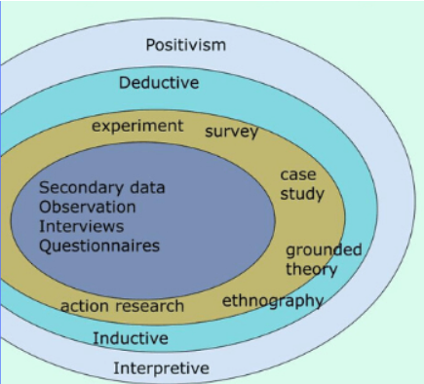

Figure 1. Sander's Onion Theory

Based on Saunders et al., (2009),Saunders Onion Theory is a conceptual framework often used in research methodology. It consists of six interconnected layers that guide researchers in structuring their research methodology effectively. Here is a summary of each layer:

1. **Research Philosophy:** This is the outermost layer, which deals with the researcher's fundamental beliefs about the nature of reality. It involves concepts like epistemology (what is considered acceptable knowledge) and ontology (the study of fact). Researchers must choose a philosophical stance, such as positivism (relying on scientific knowledge), realism (questioning the reliability of scientific knowledge), or interpretivism (emphasizing qualitative research).
2. **Research Approach:** In the second layer, researchers decide whether to adopt an inductive or deductive approach. Deductive reasoning starts from a general theory and moves toward specific hypotheses, while inductive reasoning moves from detailed observations to broader generalizations.
3. **Research Strategies:** This layer focuses on how data will be gathered, including methods like case studies, grounded theory, experiments, surveys, and archival research. Researchers might select one or multiple approaches depending on the research type.
4. **Research Choices:** Researchers decide whether to use a quantitative, qualitative, or mixed methods approach. Quantitative research relies on numerical data and statistical analysis, while qualitative research emphasizes non-numerical data, such as interviews and observations. Mixed-method research combines both techniques.
5. **Time Horizons:** This layer pertains to the time frame of the research. Researchers must choose between cross-sectional (snapshot view at a specific time) or longitudinal (study of behavior over time) research designs.
6. **Techniques and Procedures:** The innermost layer represents the core of the research methodology. Here, researchers make detailed decisions about data collection methods, ethics, questionnaire content, sample groups, and other practical aspects. These decisions should align with the choices made in the previous layers.

In summary, the Saunders Research Onion provides a structured approach for researchers to develop a comprehensive research methodology. It ensures that researchers consider philosophical underpinnings, research approaches, data collection strategies, and other crucial elements to conduct credible and well-rounded research.

In addition to a comprehensive explanation of the Saunders Research Onion model, the Author provides a visual representation of the various layers and elements of the above model, further explaining the philosophical foundation, research approach, and data collection strategy.

A visual representation of the Saunders Research Onion model, illustrating its different layers and elements. Here is an explanation of each part:

1. **Positivism and Interpretivism:** These are two contrasting philosophical stances. Positivism emphasizes using scientific methods and quantifiable data to generate objective knowledge. Interpretivism, on the other hand, focuses on understanding subjective meanings and experiences through qualitative methods.
2. **Deductive and Inductive:** These represent two different research approaches. Deductive reasoning starts with a general theory or hypothesis and tests it with specific observations or data. Inductive reasoning begins with detailed comments and seeks to derive general principles or theories from them.
3. **Experiment, Survey, Case Study, Grounded Theory, Ethnography, and Action Research:** These are various research strategies or methods that researchers can choose from, depending on their research goals and questions.
   * **Experiment:** Involves controlled experiments to test hypotheses.
   * **Survey:** Involves collecting structured data from a large sample through questionnaires or interviews.
   * **Case Study:** Focuses on in-depth exploration of a single or a few cases.
   * **Grounded Theory:** Aims to develop new theories from qualitative data.
   * **Ethnography:** Involves immersive study of a culture or group through participant observation.
   * **Action Research:** Collaborative research conducted to address real-world problems.
4. **Secondary Data, Observation, Interviews, and Questionnaires:** Data collection methods.
   * **Secondary Data:** Using existing sources such as literature reviews or previously collected data.
   * **Observation:** Directly observing and recording behaviors or events.
   * **Interviews:** Conducting structured or unstructured interviews with individuals to gather information.
   * **Questionnaires:** Administering structured sets of questions to collect data from respondents.

The central part of the onion likely represents the core of the research methodology, where researchers make specific decisions regarding data collection techniques and procedures based on their chosen methods and approaches.

Overall, this diagram visually represents how the various elements of the Saunders Research Onion model are interconnected, providing researchers with a structured framework for designing their research methodology. Researchers can select elements from each onion layer to build a comprehensive and well-planned research methodology.

### Gantt Chart and Work Breakdown Structures (WBS)

#### Gantt Chart

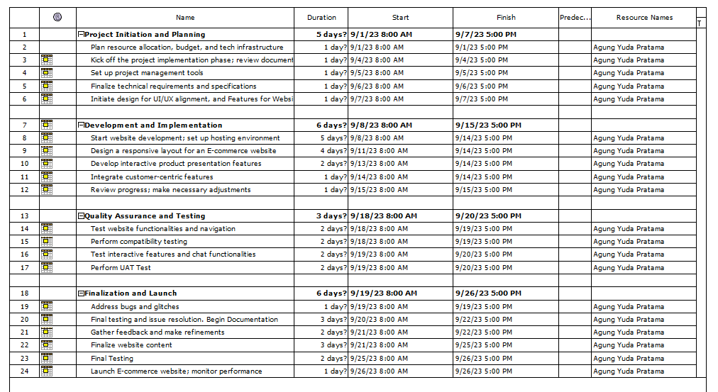

Figure 2 Gantt Chart

#### Work Breakdown Structures (WBS)

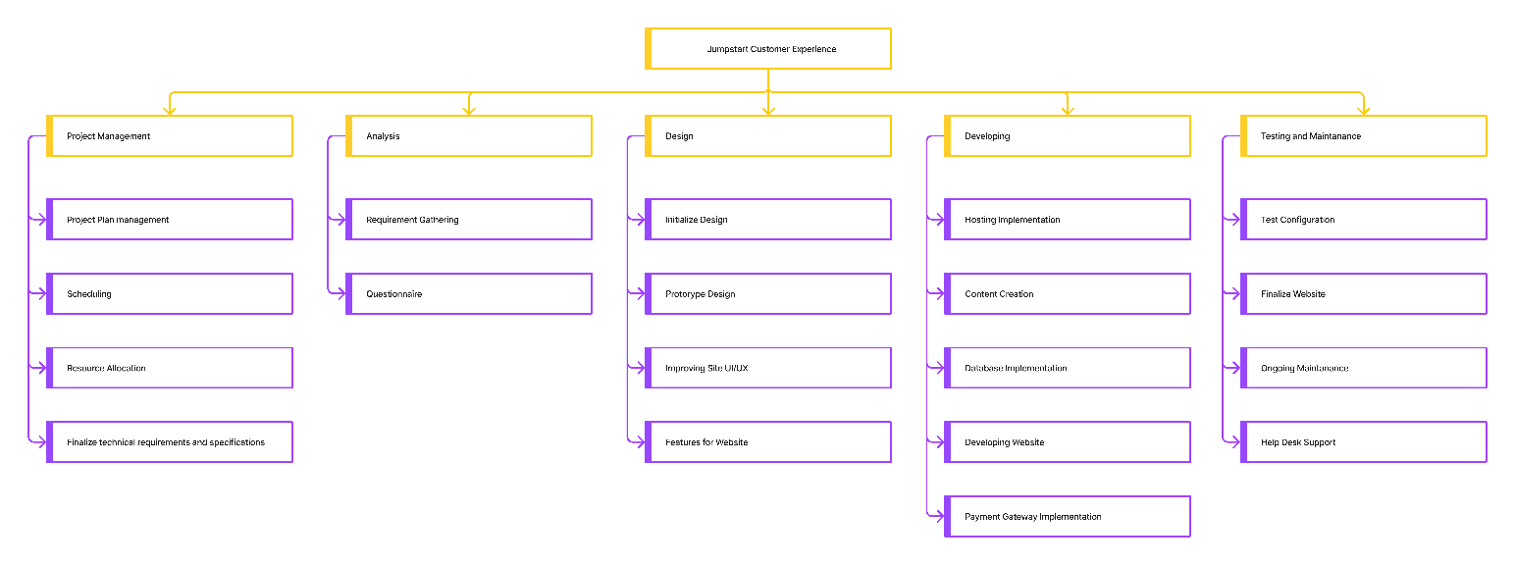

Figure 3 WBS Jumpstart

## Research Methodologies

Flick (2015) stated that research methodology is a systematic approach or strategy researchers use to design, conduct, and analyze their research. It is a plan or framework that helps researchers answer their research questions systematically and reliably. The research methodology includes various stages, including:

* Formulation of Research Question: Researchers should start by formulating a clear and specific research question that they want to answer through their research.
* Research Design: This involves selecting the most appropriate research method to answer the research question. This method can be a survey, experiment, case study, or other approach.
* Data Collection: Researchers collect data according to their research plan. This could involve interviews, observations, questionnaires, or other data collection.
* Data Analysis: The collected data is then analyzed using statistical techniques or other methods, depending on the data type and research questions.
* Interpretation of Results: Researchers should interpret the results of data analysis to answer their research questions and draw relevant conclusions.
* Writing the Research Report: The research results should be presented as a systematic research report that others can understand.
* Evaluation of Methods: Research methodology also includes critical evaluation of the methods used to ensure that the research is well conducted and the results are reliable.

Research methodology helps to ensure that the research is conducted in a scientific and accountable manner. It also helps the researcher avoid biases and errors affecting the research results. In the book, Uwe Flick explains this concept in more detail and provides practical guidance for developing an effective research methodology.

### Primary Research

Flick, (2015) illustrated that Primary Research is a type of research that involves collecting data directly from the source, rather than using existing data.

#### Survey

This method is used to collect data from several respondents using a questionnaire. It is usually done in writing or through direct interviews. This method is effective for collecting data from a large population.

#### Interview

This method involves direct interviews with respondents to obtain detailed data. Interviews can be conducted face-to-face or over the phone. This method allows researchers to explain the research topic in more depth.

#### Observations

Observation involves direct and systematic observation of specific behaviors, events, or situations. This can be done by being directly involved (participant) or indirectly (non-participant). The book will probably explain using observation as a research method and how to analyze data from observations.

#### Focus Group

Focus Group: A focus group is a method in which a representative group of people from a particular population come together to discuss a specific research topic under the guidance of a moderator. The book will probably discuss how to plan, conduct, and analyze results from focus groups as a research method.

#### Merits and Demerits for each method

|  |  |  |
| --- | --- | --- |
| Method | Merits | Demerits |
| Survey | * Allows for collecting data from a large number of respondents in a relatively short period. * Produces quantifiable data that can be analyzed statistically. * Can provide a broad picture of respondents' opinions and perceptions. | * Prone to respondent bias, who may give inaccurate or dishonest answers. * There are possible errors in filling out the questionnaire by respondents. * Sometimes, getting a high level of participation is not easy. |
| Interview | * It allows the researcher to understand respondents' views and experiences in-depth. * Flexible in terms of customizing questions and collecting additional data. * It can be used to explore the reasons and motivations behind respondents' responses. | * The time required to conduct interviews can be quite long. * Sometimes, respondents may be dishonest or give answers that are considered socially acceptable. * There is a possibility of the researcher being affected by subjective biases or interpretations in analyzing the data. |
| Observation | * Provides an in-depth understanding of the observed behavior and context. * Can produce valid and objective data because it is based on direct observation. * Allows researchers to observe things that cannot be revealed through other methods. | * Observation may be prone to researcher bias in data interpretation. * Difficult to observe infrequent events or highly personal situations. * It can take significant time and resources. |
| Focus Group | * Allows participant interaction, which can lead to new ideas and rich discussions. * Generates diverse and in-depth data through different perspectives. * Can be used to explore group understanding and social dynamics. | * Sometimes, participants tend to follow the majority opinion in the group, resulting in social conformity. * More vocal participants may dominate the discussion. * Difficult to manage large groups and ensure balanced participation. |

Table 1 Merits and Demerits for Each Method

### Secondary Research

According to Saunders et al., (2009) Secondary research involves using existing data sources, such as scientific publications, reports, or other data sources. This method uses data from other researchers or organizations to answer research questions.

In secondary research, researchers collect data from various sources that are relevant to their research topic. Then, they analyze, interpret, and reassemble the data to generate new findings or test existing hypotheses.

The advantage of secondary research is time and cost efficiency as researchers do not need to collect new data. However, researchers must ensure the data is quality, valid, and relevant to their research questions.

#### Sources of data

* Secondary Sources: Secondary data, such as industry reports, statistical data, and existing information, can be used as data sources in business research. This includes data that government agencies, business organizations, and other research institutions have collected.
* Newspapers and Magazines: You can use news articles and information from newspapers and magazines as data sources for business research, especially if you are interested in recent developments in the industry or business issues.
* Commercial Sources: Insights into using commercial data, such as market reports, financial data, and information from business service providers, as data sources for business research.

#### Secondary Research Methodologies

**Literature review**

The importance of literature review as one of the most common secondary research methods.

* Purpose of Literature Review: The primary purpose of a literature review is to understand the latest developments in a particular field of research, identify vulnerabilities in previous research, and formulate a strong theoretical basis for your research.
* Literature Review Process: This process is about conducting an effective literature review, including steps to locate and evaluate relevant literature. For the research conducted to be credible
* Synthesis and Analysis: How to synthesize and analyze the findings from the literature you reviewed and how to relate them to your research questions.

#### Merits and Demerits for each method

|  |  |  |
| --- | --- | --- |
|  | Merits | Demerits |
| Secondary Sources | * Easily accessible: Secondary data is often easily accessible through various sources such as the internet, libraries, and databases. * Efficiency: Using existing data can save time and resources required for primary data collection. * Reliable data: Data from secondary sources have often gone through a validation process and can be considered more reliable. | * Limited control: Researchers have limited control over data collection methods and the quality of existing data. * Possible data limitations: Secondary data may not fully match the needs of the research, requiring adaptation. * Potential rigor: Secondary data may not be able to describe very recent or dynamic situations well. |
| Newspapers and Magazines | * Up-to-date information: News articles can provide information on current events and trends in business and industry. * Easy access: Newspapers and magazines are widely available and easily accessible to many people. * Common understanding: News articles are often written in easy-to-understand language, allowing for a general knowledge of business issues. | * Lack of depth: News articles usually do not analyze a particular topic in-depth. * Potential bias: Newspapers and magazines can have a specific point of view or bias in their coverage. * Limited sources: News articles may not cover all relevant aspects of a topic. |
| Commercial Sources | * Relevant business data: Commercial sources can provide significant business, market, and industry data for business research. * Valuable insights: Commercial data can provide valuable insights for business decision-making. * Comprehensive: Commercial sources often cover various aspects of a business, allowing for comprehensive analysis. | * High cost: Access to commercial data usually entails high costs. * Data quality: The quality of retail data and data collection methodologies may vary, requiring further evaluation. * Reliance on external sources: Commercial sources may rely on data from third parties, which is unreliable. |
| Literature Review | * Scientific reliability: Articles in scientific journals have undergone an extensive review process and can be considered high quality. * Verified information: Scientific articles list the research methods used, allowing other researchers to verify the findings. * In-depth: Scholarly articles often provide an in-depth analysis of a particular topic. | * Limited access: Some scholarly journals require membership or subscription fees for access. * Complexity: Some scholarly articles can have complex language and methodology, difficult for lay readers to understand. * Limited to specific research: Scholarly articles may only be relevant to particular research areas. |

Table 2 Merits and Demerits

## Research Approaches

### Qualitative Research

Borrego et al., (2009) stated that qualitative research in engineering education focuses on exploring and understanding the underlying reasons, motivations, and experiences of individuals or groups. This approach often involves collecting non-numeric data, such as interviews, observations, and open-ended surveys. Here are some key aspects of qualitative research:

#### Methodologies in Qualitative Research

* **Interviews**: Researchers conduct in-depth interviews with participants to gather rich, context-specific information. Depending on the research objectives, these interviews can be structured, semi-structured, or unstructured.
* **Observations**: Researchers directly observe and document the behavior, interactions, and processes within the educational context. Observations can be participant or non-participant, providing valuable insights into real-world situations.
* **Content** **Analysis**: Content analysis involves examining textual, visual, or audio data to identify patterns, themes, and trends. It is often used to analyze documents, transcripts, or other textual materials.
* **Case Studies**: Researchers may conduct case studies to delve deeply into specific instances or cases within engineering education. Case studies involve intensive data collection and analysis within a bounded system.

#### Merits/Demerits of Qualitative Research

**Merits:**

* **Rich Data:** Qualitative research generates rich and detailed data that can provide a deep understanding of complex phenomena.
* **Contextual Understanding:** It allows researchers to explore the context and social dynamics surrounding educational experiences.
* **Flexibility:** Qualitative research is flexible and adaptive, allowing researchers to modify their approach as they gain insights during the study.

**Demerits:**

* **Subjectivity:** Qualitative research can be influenced by the researcher's subjectivity and bias, which can affect data interpretation.
* **Resource-Intensive:** Data collection and analysis often requires more time and resources than quantitative methods.
* **Limited Generalizability:** Findings from qualitative research are often context-specific and may not be easily generalized to broader populations.
* **Complex Analysis:** Analyzing qualitative data can be challenging, as it involves interpreting non-numeric data and identifying patterns.

### Quantitative Research

Borrego et al., (2009) explain that quantitative research in engineering education involves systematically collecting and analyzing numerical data to investigate relationships, patterns, and trends. It is often used to quantify the extent of phenomena, test hypotheses, and draw statistical inferences. Here are some key aspects of quantitative research:

#### Methodologies in Quantitative Research

* **Surveys**: Surveys involve the administration of structured questionnaires to a sample of participants. Researchers use surveys to gather data on attitudes, opinions, behaviors, and demographic information.
* **Experiments**: Experimental research involves manipulating one or more variables to observe their effects on an outcome of interest. This approach allows for causal inferences when carefully controlled.
* **Statistical Analysis**: Quantitative researchers often employ various statistical techniques, such as regression analysis, ANOVA (Analysis of Variance), t-tests, and correlation analysis, to analyze data and identify patterns.
* **Secondary Data Analysis**: Researchers may also use existing datasets, such as educational records or assessment scores, for quantitative analysis.

#### Merits/Demerits of Quantitative Research

**Merits:**

* **Objectivity:** Quantitative research aims for objectivity and reduces the influence of researcher bias in data collection and analysis.
* **Generalizability:** Findings from quantitative studies are often more generalizable to larger populations due to random sampling techniques.
* **Precision:** Quantitative research provides precise measurements and allows for statistical testing of hypotheses, making it suitable for establishing cause-and-effect relationships.
* **Efficiency:** It can be more efficient in data collection and analysis when dealing with large samples or datasets.

**Demerits:**

* **Lack of Depth:** Quantitative research may not capture the depth of understanding that qualitative methods offer, as it often focuses on numerical data and statistical relationships.
* **Limited Contextual Insight:** It may not provide a deep understanding of the context and the reasons behind observed patterns.
* **Assumption of Objectivity:** While quantitative research aims for objectivity, it can still be influenced by the researcher's choice of variables, measurements, and statistical methods.
* **Resource-Intensive:** Designing and conducting large-scale quantitative studies can be resource-intensive in time, money, and personnel.

### Mixed Research Approach

Borrego et al., (2009) concluded that a mixed research approach combines qualitative and quantitative research methods within a single study or research project. This approach aims to comprehensively understand a research problem by triangulating data from multiple sources. Here are some critical aspects of the mixed research approach:

#### Methodologies in Mixed Research

* **Sequential Exploratory Design**: In this design, the researcher first conducts qualitative data collection and analysis, followed by quantitative data collection and analysis. Qualitative findings may inform the development of quantitative surveys or experiments.
* **Sequential Explanatory Design**: In this design, the researcher first collects and analyzes quantitative data and then follows up with qualitative data collection and analysis. Qualitative data may be used to explain or provide context for quantitative findings.
* **Concurrent Design**: In this design, both qualitative and quantitative data are collected simultaneously but analyzed separately. Researchers compare and integrate the findings to better understand the research problem.

#### Merits/Demerits of Mixed Research

**Merits:**

* **Comprehensive Understanding:** The mixed research approach allows researchers to gain a more comprehensive understanding of a research problem by drawing on the strengths of qualitative and quantitative methods.
* **Triangulation:** By using multiple data sources and methods, researchers can triangulate findings, increasing the validity and reliability of their results.
* **Confirmation and Exploration:** Quantitative data can confirm or refute hypotheses, while qualitative data can explore the reasons behind observed patterns or relationships.
* **Enhanced Credibility:** Combining qualitative and quantitative data can enhance the credibility of the study's findings and provide a more robust basis for conclusions.

**Demerits:**

* **Complexity:** Conducting mixed research can be complex and time-consuming, requiring expertise in both qualitative and quantitative methods.
* **Resource-Intensive:** It may require more data collection, analysis, and personnel than single-method approaches.
* **Integration Challenges:** Integrating qualitative and quantitative findings can be challenging, and researchers must carefully consider how to merge and interpret the data.
* **Sequential Designs May Be Lengthy:** Sequential designs may extend the duration of the research project, especially if one phase depends on the findings of the other.

## Research Design

### Saunders Research Onion Theory

According to Saunders et al., (2009), The Saunders Research Onion is a conceptual framework used in research methodology, consisting of six interconnected layers. The outermost layer, Research Philosophy, deals with the researcher's fundamental beliefs about reality, such as positivism, realism, or interpretivism. Researchers must choose a philosophical perspective depending on their philosophical stance, such as positivism, authenticity, or interpretivism.

The second layer, the Research Approach, decides whether to adopt an inductive or deductive approach, starting from a general theory and moving toward specific hypotheses. The third layer, Research Strategies, focuses on how data will be gathered, including methods like case studies, grounded theory, experiments, surveys, and archival research. Researchers must also decide whether to use a quantitative, qualitative, or mixed methods approach.

The time horizon layer pertains to the time frame within which the research will be conducted, with researchers choosing between cross-sectional or longitudinal research designs. The innermost layer, Techniques and Procedures, represents the core of the research methodology, where researchers make detailed decisions about data collection methods, ethics, questionnaire content, sample groups, and other practical aspects.

The Saunders Research Onion provides a structured approach for researchers to develop a comprehensive research methodology, considering philosophical underpinnings, research approaches, data collection strategies, and other crucial elements to conduct credible and well-rounded research. A visual representation of the model illustrates its various layers and components, visually representing its interconnected parts and providing researchers with a structured framework for designing their research methodology.

### Compare research methods and research approaches

**Comparison of data Approaches based on** Borrego et al., (2009)

|  |  |  |
| --- | --- | --- |
| Quantitative Research | Qualitative Research | Mixed Research |
| * Theory is used to support the variables and research questions * Data in the form of numbers and statistics. * Generalization of research results to a larger population. * Questions focus on the relationship between variables and measurements. * Results are represented in numbers and graphs * Objective, generalization, precise measurement, easy replication. | * Text-oriented approach that focuses on describing the context * Data in the form of text, narratives, and interview quotes * Understand the phenomenon and describe the context. * Questions focus on meaning, perception, and experience. * Results are represented in narrative descriptions * Deep context, deep understanding, flexible. | * A combination of theory and context approaches. * A combination of quantitative and qualitative data. * Gain deeper understanding by involving multiple data collection. * Combination of quantitative and qualitative questions. * Qualitative results support the interpretation of quantitative results. * Provides comprehensive understanding by combining quantitative and qualitative strengths. |

Table 3 Comparison of Quantitative, Qualitative, and Mixed Methods

Conclusion: Quantitative research uses structured data collection instruments and measurable methods to collect accurate and reliable data for answering research questions. This approach allows for generalization and replication of findings, allowing for more inferences about the wider population and testing the validity and reliability of results. Quantitative data, collected in numbers and statistics, provides advantages in data analysis by identifying patterns, relationships, and trends that qualitative methods may struggle to find. It also facilitates objective interpretations and firm conclusions based on facts. Quantitative research methods are more efficient and scalable, as they allow for data collection from a larger number of respondents, increasing the validity of the findings.

**Comparison among primary methods based on** Creswell & David Creswell, (2018)

|  |  |  |  |
| --- | --- | --- | --- |
| Survey | Interview | Focus group | Observation |
| * Quantitative data. * Collecting data from respondents through questionnaires or surveys. * Collects structured and objective data. * Measures respondents' preferences, attitudes, or demographic characteristics. * Can be conducted in large studies with large samples. | * Qualitative data. * Direct interviews between researchers and respondents. * Gain an in-depth understanding of individuals' views, experiences, and perspectives. * Explain and elicit complex and detailed information. * Used in smaller, in-depth studies. | * A small group discussion guided by a moderator. * Share views, experiences, and opinions on a specific topic. * Gain richer insights and perspectives through interaction between participants. | * Direct observation of specific behaviors, interactions, or situations. * Gain an in-depth understanding of the context and dynamics at play. * See and record behaviors that cannot be explained through interviews or surveys. |

Table 4 Comparison Survey, Interview, Focus Group, and Observation

Conclusion: Surveys are an effective method for collecting objective and structured data, measuring preferences, attitudes, or characteristics, and obtaining a representative sample. They can be conducted in a short time and cover a large number of respondents, making data collection more efficient than other research methods. Surveys also allow for advanced statistical analysis, such as regression, factor analysis, or t-test, to provide more in-depth findings. They can be conducted using appropriate sampling techniques and can be conducted in a relatively short time, making them an efficient and time-saving research method.

**Comparison of secondary methods according to** Goulding, (2005) **and** Creswell & David Creswell, (2018)

|  |  |  |  |
| --- | --- | --- | --- |
| Literature Review | Grounded Theory | Case Study | Ethnography |
| * Review, analyze, and synthesize existing research on a particular topic. * The approach uses Document Analysis. * The data collected is secondary data from existing literature. * Text analysis and general findings | * Involves collecting data through in-depth interviews, observations, and memos, analyzing it. * Consists of a core category, tracing back to data, using life histories, secondary data, introspection, and numbers to explain a phenomenon. * Inductive approach. * The data collected is primary data from observations or interviews. * Data analysis using text analysis and theory development | * Understanding complex phenomena in real context. * Approach using descriptive explorative. * The data obtained are primary data from interviews, observations, and documents. * Data analysis uses qualitative analysis, general findings, and in-depth descriptions. | * Explores social meanings in material possessions, focusing on cultural communication and structured patterns of action * Using methods like surveys, observational data, and recordings to understand how culture is constructed through their behaviors and experiences. * Data analysis involves content analysis, categorizing words based on inherent concepts, and regrouped under thematic headings |

Table 5 Comparison Literature Review, Grounded Theory, Case Study, and Ethnography

Conclusion: Literature reviews are essential for building a solid theoretical foundation for research. They help understand existing concepts, identify research gaps, and identify relevant theories. They also help determine the suitable methodology by learning from previous research methods and selecting the appropriate approach for the research question. Literature reviews also help identify relevant data sources, ensuring valid and high-quality data is collected. They strengthen the argumentation of the research by referencing previous studies and supporting claims and findings with evidence. They also increase the validity of the research by demonstrating its connection to previous research. Literature reviews offer new insights and inspiration, allowing researchers to develop ideas and view the research topic differently.

## Research Conduct and Analysis

### Conduct Primary Research

**Survey:** The complete process of conducting the survey:

1. consider costs, access, and ethical issues

|  |  |
| --- | --- |
| **Survey_Considerations** | **Description** |
| *Cost* | Google Forms is an open-source tool for creating the survey form. The participants only need to use the internet to participate in surveys. |
| Access | Can access anywhere internet access. |
| Ethical | Make sure that the participants agree the consent to do the surveys. All the data are kept confidential. |

Table 6 Survey Consideration

1. **Objective of the survey**: to understand the Pain points of Jumpstart during COVID-19 and to know customer experience for the solution they expect.
2. **Identify the tool:** Google Form
3. **Frame question**

Questionnaire

1. Are you already a Jumpstart Tech customer before COVID-19?

* Yes, I am a current customer.
* No, I have never been a customer.

2. How frequently do you visit the Jumpstart Retail before COVID-19?

* Always
* Often
* Sometimes
* Rarely
* Never

3. How satisfied are you with Jumpstart's current e-commerce platform and its ability to provide a seamless online shopping experience?

* Very Satisfied
* Satisfied
* Neutral
* Dissatisfied
* Very Dissatisfied

4. How often have you encountered product unavailability or stockouts while shopping on Jumpstart's website or app during COVID-19?

* Never
* Rarely
* Sometimes
* Often
* Always

5. How about the clarity and informativeness of product descriptions and images provided by Jumpstart on its website or app?

* Yes. The product descriptions and images are very clear and informative.
* No. The product descriptions and images are unclear and lack information.

6. Have you ever chosen to purchase from a competitor due to product unavailability on Jumpstart's platform?

* Yes, I switched to a competitor.
* No, I waited for the product to become available.

7. How important is it to you that Jumpstart's e-commerce platform offers a consistent and user-friendly shopping experience across various devices (desktop, mobile, tablet)?

* Extremely important
* Very important
* Moderately important
* Slightly important
* Not important at all

8. How would you rate the speed and performance of the Jumpstart website when you search for products or shop online?

* Very slow and poor performance
* Slow and below average performance
* Moderate speed and performance
* Fast and above-average performance
* Very fast and excellent performance

9. Do you tend to look for and use product reviews or recommendations from other customers before making a purchasing decision on the Jumpstart e-commerce platform?

* Yes, I always read reviews and recommendations.
* No, I never use reviews and recommendations.

10. Would you be will to pay a slightly higher price for products if it ensured that Jumpstart's e-commerce platform consistently maintains products in stock and higher quality?

* Yes, I would pay a slightly higher price.
* No, I prefer lower prices even if it means occasional stockouts.

11. How satisfied are you with Jumpstart's current return and exchange policy for out-of-stock items?

* Very satisfied
* Satisfied
* Neutral
* Dissatisfied
* Very dissatisfied

12. Have you ever experienced any issues with Jumpstart's e-commerce platform that negatively affected your shopping experience after COVID-19?

* Always
* Often
* Sometimes
* Rarely
* Never

13. How likely are you to recommend Jumpstart to a friend or colleague based on your experiences with its e-commerce platform?

* Very Likely (I would highly recommend)
* Likely (I would recommend)
* Neutral (I might or might not recommend)
* Unlikely (I would hesitate to recommend)
* Very Unlikely (I would not recommend)

14. Do you prefer shopping online on the Jumpstart website or at a physical store after COVID-19?

* I prefer online shopping on the Jumpstart website.
* I prefer shopping at a physical store.

1. **Population Sampling**:

Categorization of participant

1. Participant may be customer Jumpstart or not
2. The Participant knows what Jumpstart is
3. Participants had purchased computer products manually in stores (no need in jumpstart retail) in the pre-covid era
4. Participant can understand and read English
5. Participant has to use the Internet to fill out the survey
6. Participants are interested in doing a survey
7. **Distribute the survey** : Via WhatsApp, and email with 20 Participants.
8. **Collect and analyze results**:

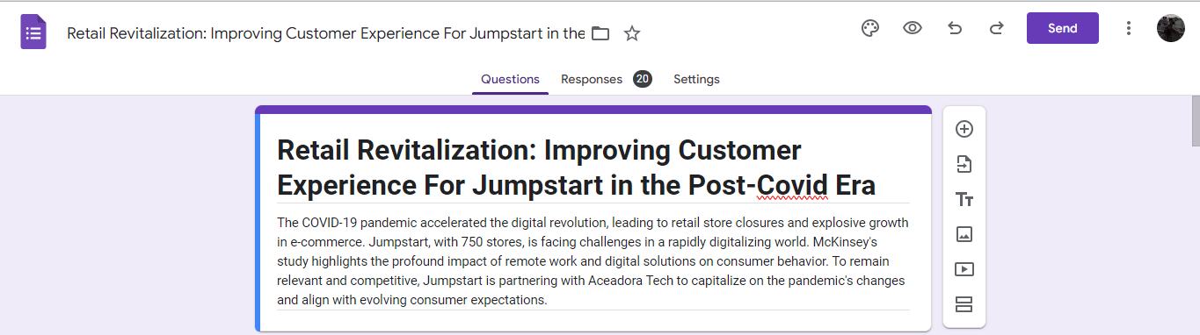

Figure 4 Questionnaire Title

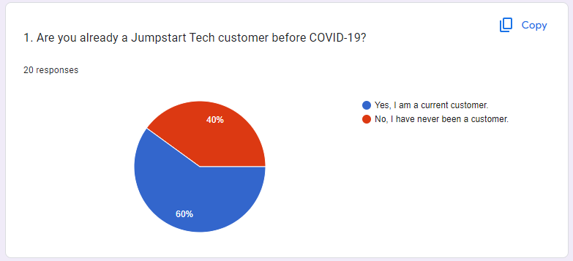

Figure 5 Question Number 1

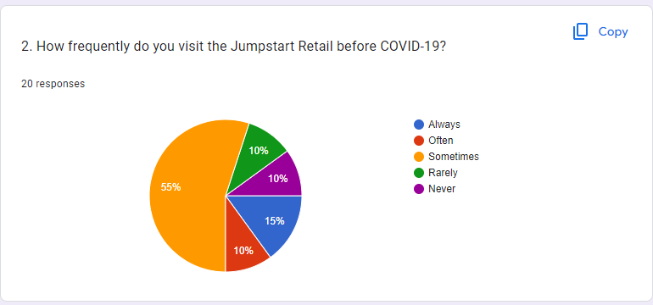

Figure 6 Question Number 2

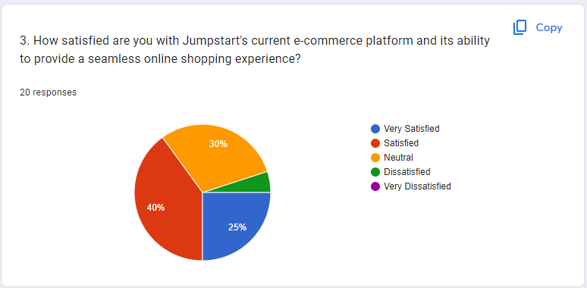

Figure 7 Question Number 3

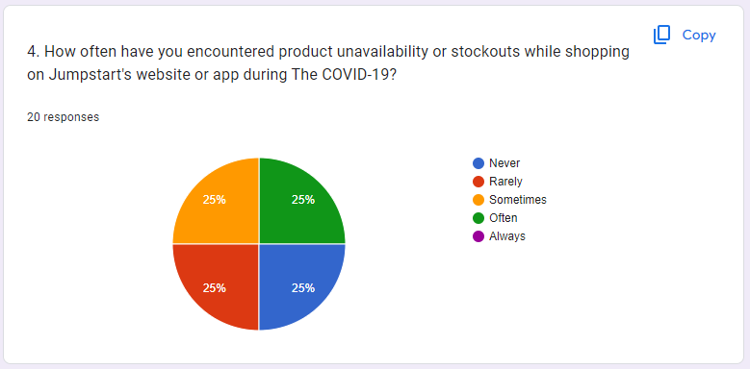

Figure 8 Question Number 4

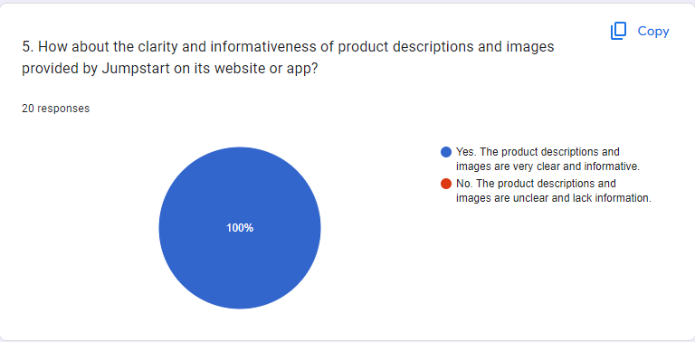

Figure 9 Question Number 5

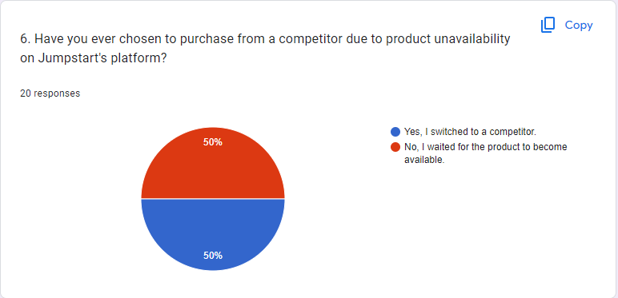

Figure 10 Question Number 6

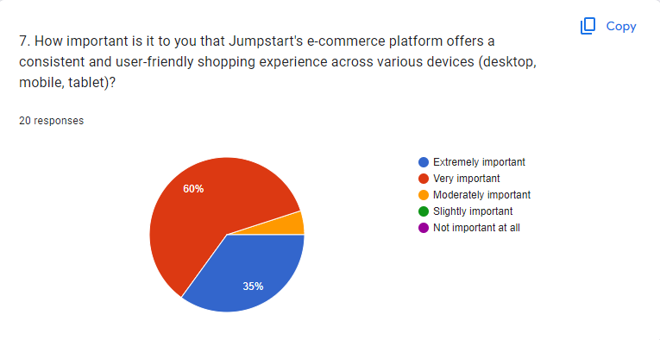

Figure 11 Question Number 7

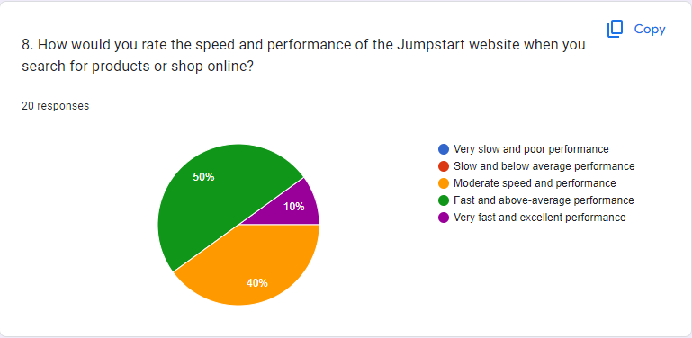

Figure 12 Question Number 8

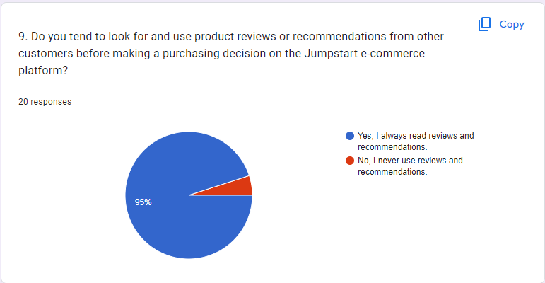

Figure 13 Question Number 9

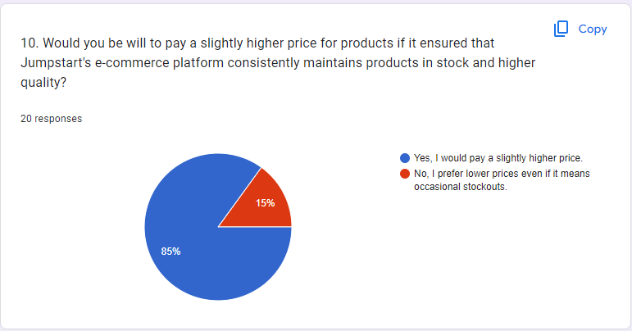

Figure 14 Question Number 10

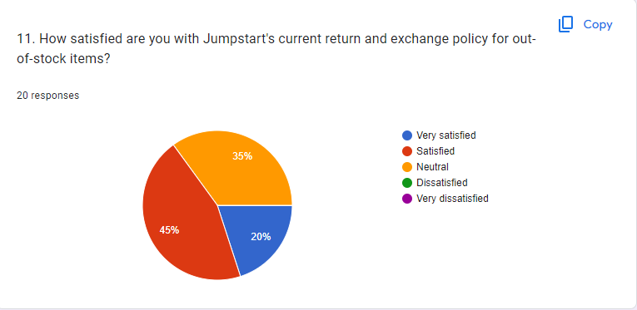

Figure 15 Question Number 11

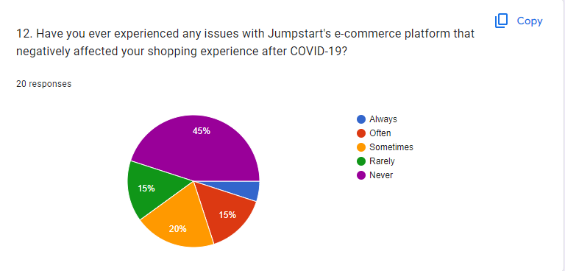

Figure 16 Question Number 12

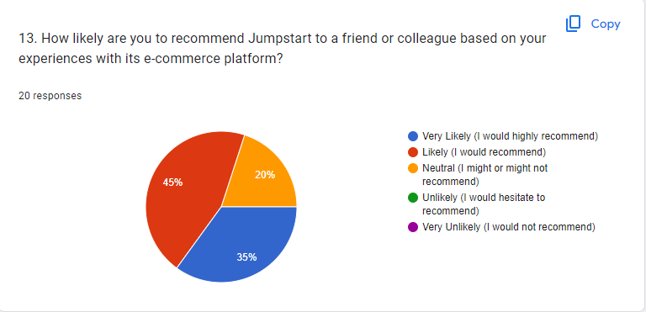

Figure 17 Question Number 13

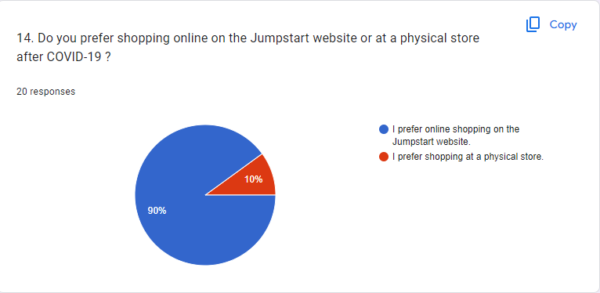

Figure 18 Question Number 14

**Conclusion**:

**Experience Before COVID-19:**

Most respondents (57.1%) were Jumpstart customers before COVID-19, while the rest (42.9%) had never been customers.

**Frequency of Visits Before COVID-19:**

The majority of respondents (52.4%) visited Jumpstart regularly before the pandemic, although most also admitted that they only saw it sometimes (38.1%).

**Satisfaction with Current E-commerce Platform:**

The majority of respondents (56.1%) expressed satisfaction or very satisfaction with Jumpstart's current e-commerce platform. However, one respondent (4.8%) claimed to be dissatisfied.

**Product Availability Issues (Stockouts):**

Most respondents (52.4%) claimed to have experienced stockouts while shopping on Jumpstart's e-commerce platform during the pandemic. This is an area that needs improvement.

**Product Descriptions and Images:**

The majority of respondents (95.2%) felt that product descriptions and images on Jumpstart's platform were clear and informative.

**Switching to Competitors due to Product Availability:**

Many respondents (47.6%) claimed to have changed to competitors due to a lack of product availability on the Jumpstart platform. This indicates that the issue of product availability is a significant concern.

**Consistency and Friendly User Experience across Devices:**

Most respondents (66.7%) felt that consistency and friendly user experience across devices are important or very important.

**Website Speed and Performance:**

Most respondents (61.9%) consider Jumpstart's website speed and performance good, although there is room for improvement.

**Using Product Reviews and Recommendations:**

Most respondents (90.5%) always read product reviews and recommendations before purchasing on Jumpstart's e-commerce platform.

**Readiness to Pay a Slightly Higher Price:**

Most respondents (85.7%) are willing to pay a slightly higher price if it guarantees product availability and better quality.

**Satisfaction with Return and Exchange Policy:**

Most respondents (57.1%) were satisfied with Jumpstart's return and exchange policy.

**Issues Affecting Shopping Experience:**

Several respondents (38.1%) claimed to have experienced issues that affected their shopping experience on Jumpstart's e-commerce platform during the pandemic. While (61.9%) Respondents had fewer problems while shopping

**Likelihood to Recommend Jumpstart:**

Most respondents (66.7%) said they would likely recommend Jumpstart to their friends or colleagues based on their experience with the e-commerce platform.

**Preferences for Shopping Online vs. Physical Stores:**

Most respondents (85.7%) prefer shopping online on Jumpstart's website over shopping at physical stores after the pandemic.

### Conduct Secondary research

**Literature Review**

Consider costs, access, and ethical issues.

|  |  |
| --- | --- |
| **Literature Review** | **Description** |
| Cost | Sciencedirect.com, tandfonline.com, schoolar.google.com, sci-hub.se, and libgen.is. The website that The Author uses is free and has authorization. |
| Access | Can access anywhere internet access. |
| Ethical | If it is a book, the publication year should not exceed 2000; if it is a journal, ensure the publication year should not exceed 2017. |

Table 7 Literature Review Consideration

(a) Table Literature Review

|  |  |  |  |  |
| --- | --- | --- | --- | --- |
| No. | Title | Author | Year | Outcomes |
| 1 | Research on Remote Work in the Era of COVID-19 | T. Jacks | 2021 | Remote work offers numerous benefits, including flexibility, cost savings, and innovation. However, it also poses challenges, such as exacerbating digital inequities, job losses, and changing work culture. Despite these challenges, remote work offers benefits such as work-life balance, cost savings, and global reach. However, it raises concerns about information security and privacy, the digital divide and disparity, and productivity impacts.  Future research should focus on understanding the economic and social consequences of remote work in regions lacking IT infrastructure and stable internet access, as well as the accessibility and affordability of technology. Empirical research should assess the impact of remote work on organizational and individual productivity, explore new institutional logic, and provide a global perspective on remote work. The long-term effects of remote work should also be studied, considering its lasting impact beyond the immediate pandemic response and its implications for various industries and sectors. |
| 2 | Customer Experience Challenges: Bringing Together Digital, Physical and Social Realms | Ruth N. Bolton, et al. | 2020 | The article by Ruth N. Bolton et al. highlights the multidimensional nature of customer experience (CX), encompassing digital, physical, and social realms. It emphasizes the importance of businesses considering these dimensions to create a seamless customer journey. The authors highlight the impact of digitalization on CX, emphasizing the need to optimize digital touchpoints. Physical touchpoints are crucial in sectors like retail and hospitality, but maintaining consistency across locations is challenging. Social interaction plays a significant role in shaping CX, with social media and user-generated content influencing brand perceptions. The integration challenges businesses face include achieving consistency and coherence across these dimensions and adapting to changing customer behaviors. The article also provides practical managerial insights, emphasizing a customer-centric approach, data analytics, and organizational agility in responding to evolving CX dynamics. |
| 3 | Digital Transformation: A Multidisciplinary Reflection and Research Agenda | Peter C. Verhoef, et al. | 2019 | This journal emphasizes the significance of digital transformation in today's business and organizational context. It underlines the need for organizations to adapt to changing technology and customer needs. The journal also emphasizes the importance of a multidisciplinary approach in understanding and implementing digital transformation, which includes technology, business strategy, change management, and marketing. Cross-disciplinary collaboration is crucial for optimizing outcomes. The research agenda covers digital transformation strategies, the influence of new technologies, organizational and cultural impacts, changes in customer relationships, and risk management. The journal also discusses the practical implications of digital transformation, emphasizing the need for solid leadership, interdepartmental collaboration, digital skills development, and deep customer understanding. The journal provides valuable guidance for organizations undergoing digital transformation successfully. |
| 4 | Tourism and COVID-19: Impacts and Implications for Advancing and Resetting Industry and Research | M. Sigala | 2020 | The COVID-19 pandemic has devastated the global tourism industry, leading to a sudden decline in tourism activities, travel restrictions, and business closures. The author emphasizes the importance of resilience, digital transformation, and innovation in mitigating the pandemic's effects. Businesses have turned to online platforms, contactless technologies, and virtual experiences to maintain customer connections and adapt to changing consumer behaviors. The crisis presents an opportunity for the industry to prioritize sustainability as a core principle. The pandemic has also led to significant shifts in consumer behavior, including changes in travel preferences, health and safety concerns, and the demand for personalized experiences. The article calls for research on the resilience of tourism systems, the impact of digitalization, and sustainable tourism practices. It also offers practical insights for tourism managers and policymakers, suggesting strategies for recovery, safety measures, and adapting to changing market dynamics. This research is a valuable resource for scholars, industry professionals, and policymakers seeking to navigate the challenges and opportunities of the pandemic in the tourism sector. |
| 5 | Use of customer satisfaction measurements to drive improvements | A. Birch-Jensen, I. Gremyr, J. Hallencreutz, & Å. Rönnbäck | 2018 | Customer satisfaction is a critical performance metric for organizations, indicating how well a product or service meets customer expectations and needs. It is measured using various methods like surveys, interviews, and data analysis, which help organizations understand customer perceptions and identify areas for improvement. Using customer satisfaction data can help identify trends, compare performance with competitors, identify opportunities for improvement, and measure the impact of corrective actions. Management and employees are crucial in utilizing customer satisfaction data to drive improvements. Translating customer satisfaction data into actionable improvements is central to the article. Organizational learning and adaptation are also discussed, with a customer-centric approach leading to continuous improvement efforts. Employee engagement is also emphasized, focusing on cultivating a customer-centric culture. Challenges and barriers to practical customer satisfaction measurements include data quality, interpretation, and resistance to change. |

Table 8 Literature Review

# Project Part (Part II)

## Project Proposal

## Project Objective

The objectives of this project are designed to address the core challenges faced by Jumpstart and to deliver measurable outcomes that positively impact the company's performance:

1. **Enhance Customer Satisfaction:**

The primary objective is to elevate customer satisfaction by creating a seamless, personalized, and engaging shopping experience through the newly developed E-commerce website. By ensuring accessibility around the clock, customers will be free to explore and make purchases whenever and wherever they desire.

1. **Increase Customer Loyalty:**

By offering compelling promotions, discounts, and free delivery options on the E-commerce platform, the project aims to increase customer loyalty. This enhanced loyalty will lead to repeat purchases, stronger brand relationships, and a heightened attachment to Jumpstart's offerings.

1. **Drive Revenue Growth:**

Through the improved customer experience delivered by the E-commerce website, the project intends to contribute to the overall revenue growth of the Jumpstart retail chain. Enhanced customer satisfaction and loyalty will translate into increased sales, conversions, and average transaction values.

1. **Optimize Operational Efficiency:**

Technology solutions and process automation will be strategically integrated to optimize operational efficiency. By reducing manual tasks and minimizing errors, these enhancements will lead to streamlined operations, reduced costs, and improved overall productivity.

## Project Scope

The scope of this project includes:

* We are developing an E-commerce website with responsive design, interactive product presentation, and consistent UI design.
* We are implementing technology solutions to enable 24/7 access for customers.
* Enhancing customer experience through promotions, discounts, and free delivery options.
* We conduct surveys and research to gather insights into customer preferences and behaviors.

## Project Constraints

**Time constraints:**

The project had to be completed between September 1 - September 26 to align with Jumpstart's business objectives.

**Budget constraints:**

The project operated within a predetermined budget of $2110, which may have limited the allocation of resources to specific activities and could have had an adverse impact in the event of technical errors

**Resource Constraints:**

The project team may face constraints regarding the availability of skilled personnel with expertise in technology, marketing, design, and operations. A lack of people will result in the length of the project process.

**Quality Constraints:**

The project is expected to adhere strictly to high-quality standards, including enhancing customer experience and integrating cutting-edge technological innovations. It is essential to realize that individual interpretations of quality may be different, leading to differences in perceived standards.

**Risk Constraints:**

The deployment of technology, consumer acceptability, unplanned disruptions, and the possible impact of natural disasters are just a few risks that could prevent project advancement.

**Stakeholder Constraints:**

Managing and meeting the expectations of various stakeholders, including senior management, IT teams, marketing, and customer support, can be challenging if their expectations are not met.

## Project Assumptions

1. **Technology Assumptions:** Technology assumptions are the hardware, software, apps, or frameworks the project team may require throughout the project's stages.
   * 1. **Hardware**:

* Processor: Dual Core 2.8 GHz
* Ram: 4GB
* Storage: 50GB
  + 1. **Software**:
* Windows 10 / 11
* CMS (WordPress)
  + 1. **Framework**
* Woo Commerce
* Elementor
* Astra
* Formidable
* Chaty

1. **Facility Assumptions:** Facility assumptions regarding the potential locations for project production. Another facility assumption may be the office area where the team can work and arrange information.
   * 1. **Tools:** Google Form (Questionnaire)
2. **Design Assumptions:** Design assumptions regarding the many design methods or tools a team may employ when working on a project. Another design assumption is that the team can use the project-specific requirements of the company's existing design software.

The Author will make the E-Commerce website to reach out to the customer. E-Commerce must have :

* + 1. Responsive Design
    2. Interactive Product Presentation
    3. Consistent UI Design

## Project Environment

|  |  |
| --- | --- |
| Software | * Windows 10 / 11 * CMS WordPress License Premium * Plugin License Premium |
| Hardware | * Intel Xeon Silver 4210 2.2GHz Turbo 3.2GHz * 32 GB * 4 TB * 2TB NVMe Gen. 4 * Gigabit Network * Asus TUF VG328H1B 31.5" * Seasonic Prime Titanium TX-1000 - 1000W 80+ Titanium Certified * USB Mouse Keyboard |

Table 9 Project Environment

**Technologies:**

1. **CMS (Content Management System):** The website will be built using WordPress, a popular CMS that provides a user-friendly interface for content management, making it easy to update and maintain the site's content. **WordPress 6.3.1**
2. **Web Hosting:** The website will be hosted on a web server to make it accessible online. Hosting services like Pantheon will be used to ensure reliability and performance.

**PANTHEON**

1. **Database Management System (DBMS):** A DBMS will store and manage product, customer information, and transaction data.

**MySQL WorkBench 8.0**

1. **Web Browsers:** The website will be designed to be compatible with major web browsers such as Google Chrome, Mozilla Firefox, and Microsoft Edge to ensure a consistent and accessible user experience.

**Programming Languages:**

1. **HTML (Hypertext Markup Language):** HTML will be used to structure the content of web pages, defining elements like headings, paragraphs, lists, and links. **HTML 5**
2. **CSS (Cascading Style Sheets):** CSS will style and format the website's layout, defining aspects like fonts, colors, and responsive design for different screen sizes. **CSS 3**
3. **JavaScript:** JavaScript, a versatile scripting language, will be utilized to enhance the website's interactivity and user experience. It can be used for client-side validation, dynamic content updates, and interactive features. **JavaScript ES6**
4. **PHP (Hypertext Preprocessor):** PHP will be used for server-side scripting to handle dynamic content generation, database interactions, and server-side processing. It enables the website to perform tasks like user authen

**Frameworks:**

1. **WooCommerce v2.2.2:** WooCommerce is an e-commerce plugin for WordPress providing a framework for managing product listings, shopping carts, checkout processes, and payment gateways. It is highly customizable to suit the specific needs of the E-commerce website.
2. **Elementor v3.15.3:** Elementor is a popular page builder plugin for WordPress that creates custom page layouts using a drag-and-drop interface. It simplifies the design and customization of web pages, making them user-friendly for website administrators.
3. **Astra:** Astra is a lightweight and highly customizable WordPress theme that can be used as a framework for designing the website's layout and appearance. It offers flexibility and performance optimization.
4. **Formidable v6.4.2:** Formidable is a form builder plugin for WordPress, which can be used to create and manage forms for various purposes on the website, such as contact forms, surveys, and feedback forms.
5. **Chaty v3.1.4:** Chaty are plugins or tools that can be integrated into the website to provide real-time chat support and engage with customers, enhancing the overall customer experience.

## Project Design

### Project Flowchart

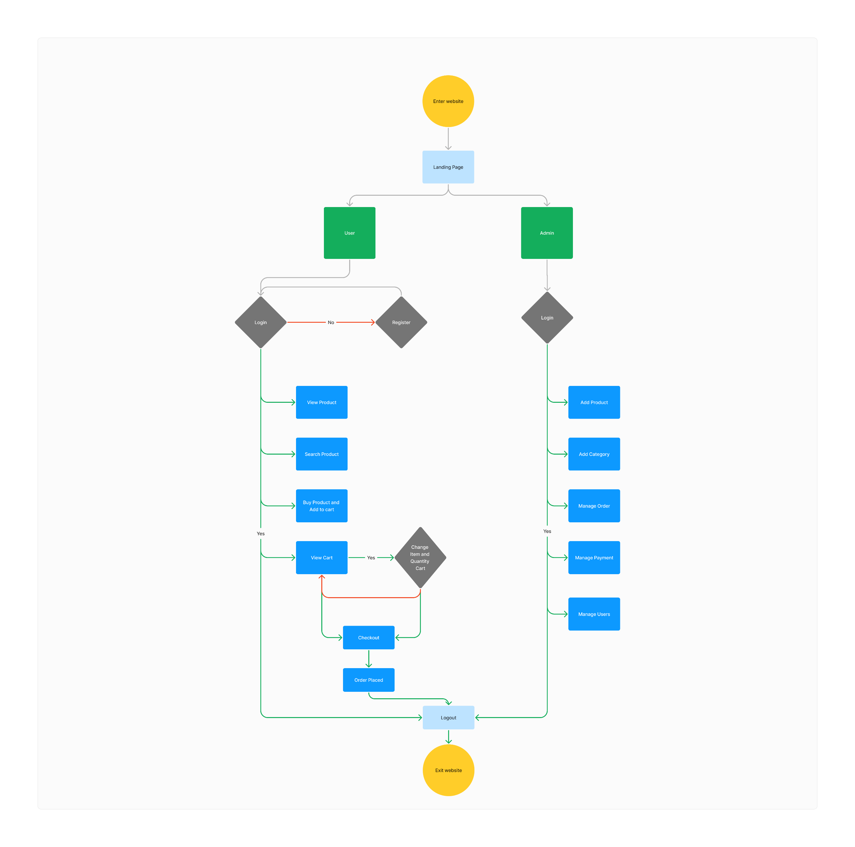

Figure 19 Flowchart Jumpstart

### Project Wireframes

**LANDING PAGE**

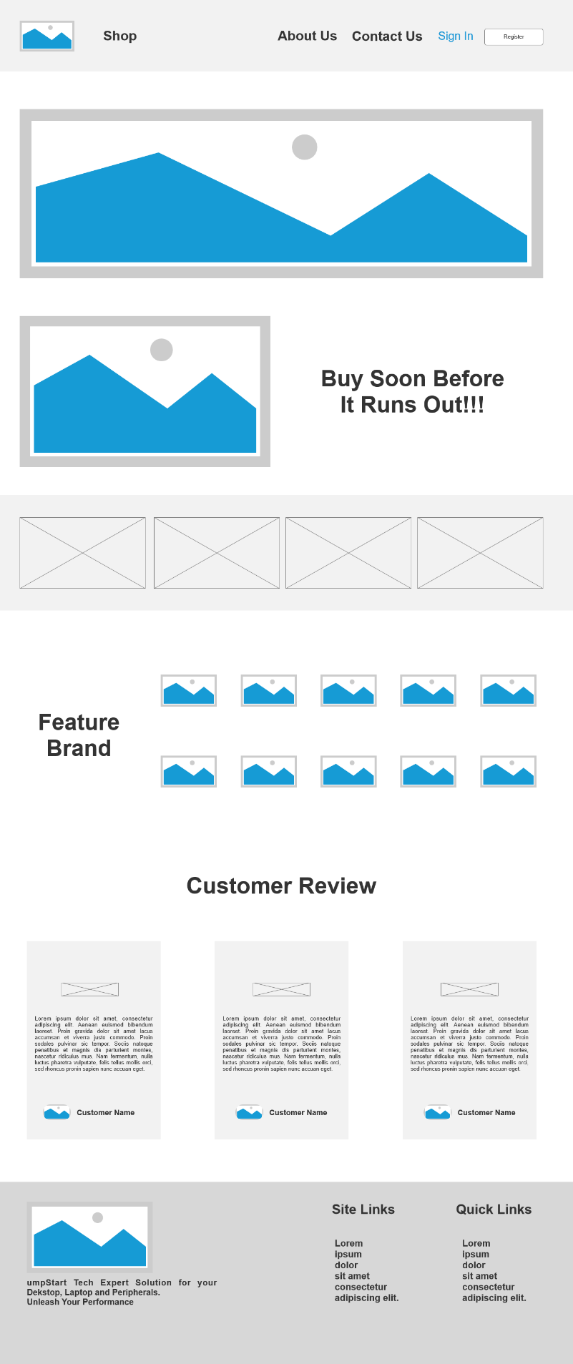

Figure 20 Landing Page Wireframe

**ABOUT US**

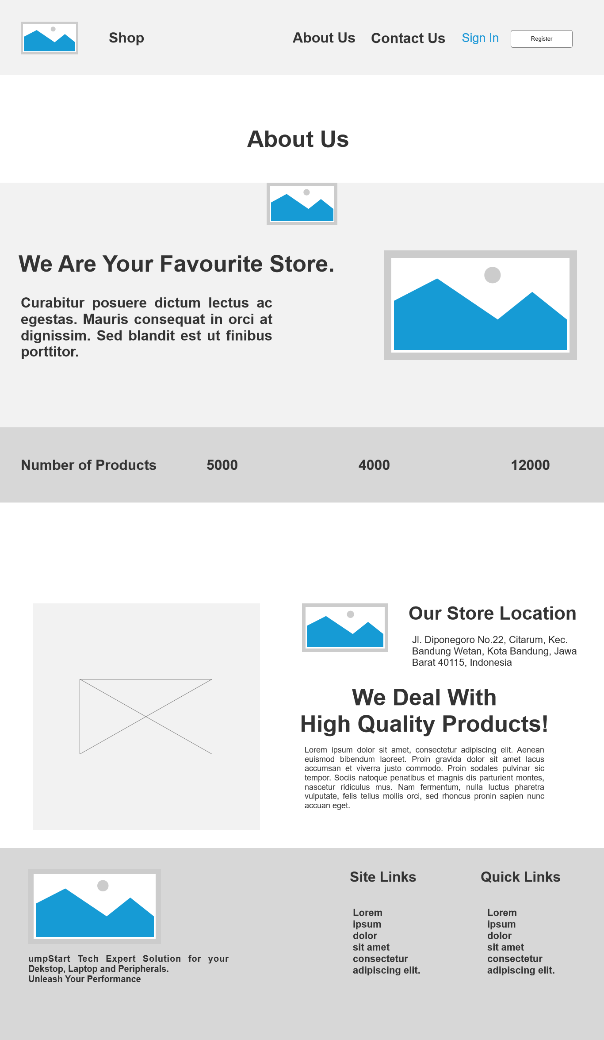

Figure 21 About Us Wireframe

**CONTACT US**

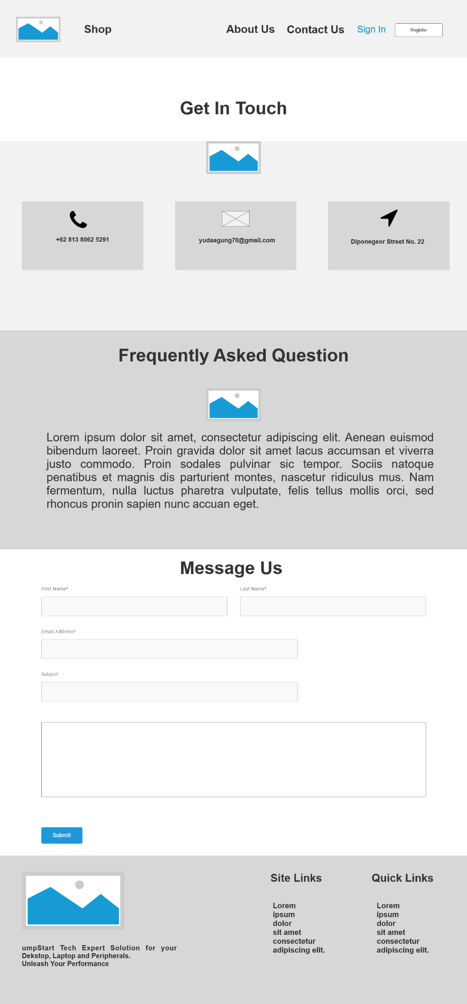

Figure 22 Contact Us Wireframe

**PRIVACY POLICY**



Figure 23 Privacy Policy Wireframe

**REFUND AND RETURN POLICY**

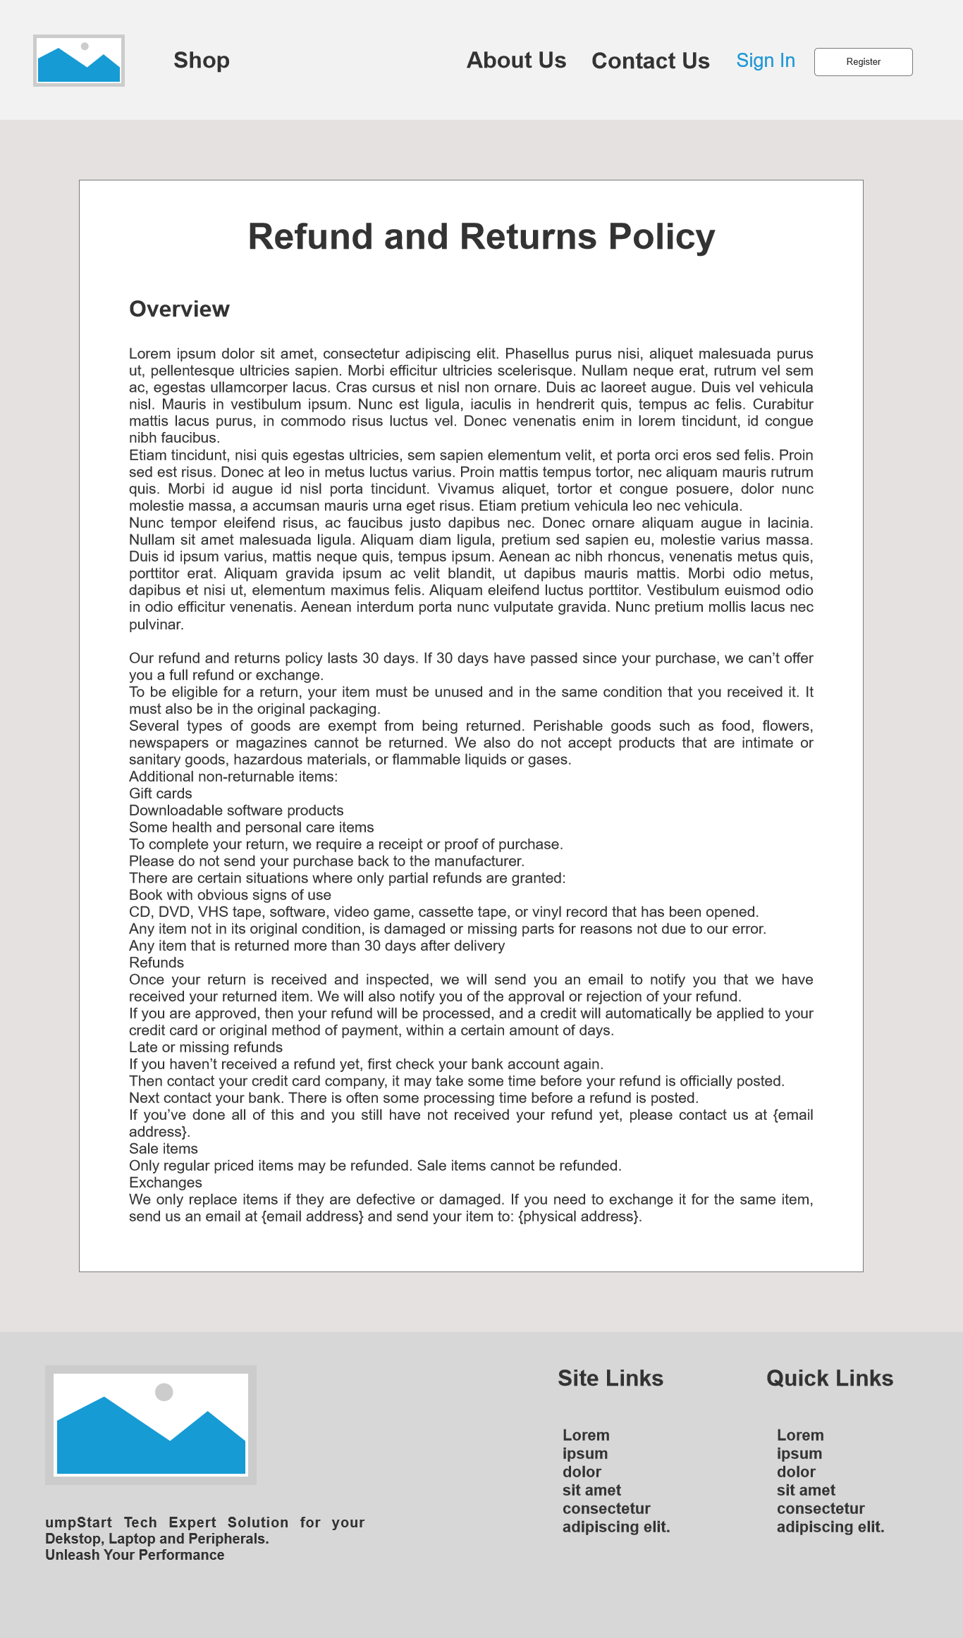

Figure 24 Refund and Return Policy

**REGISTER**

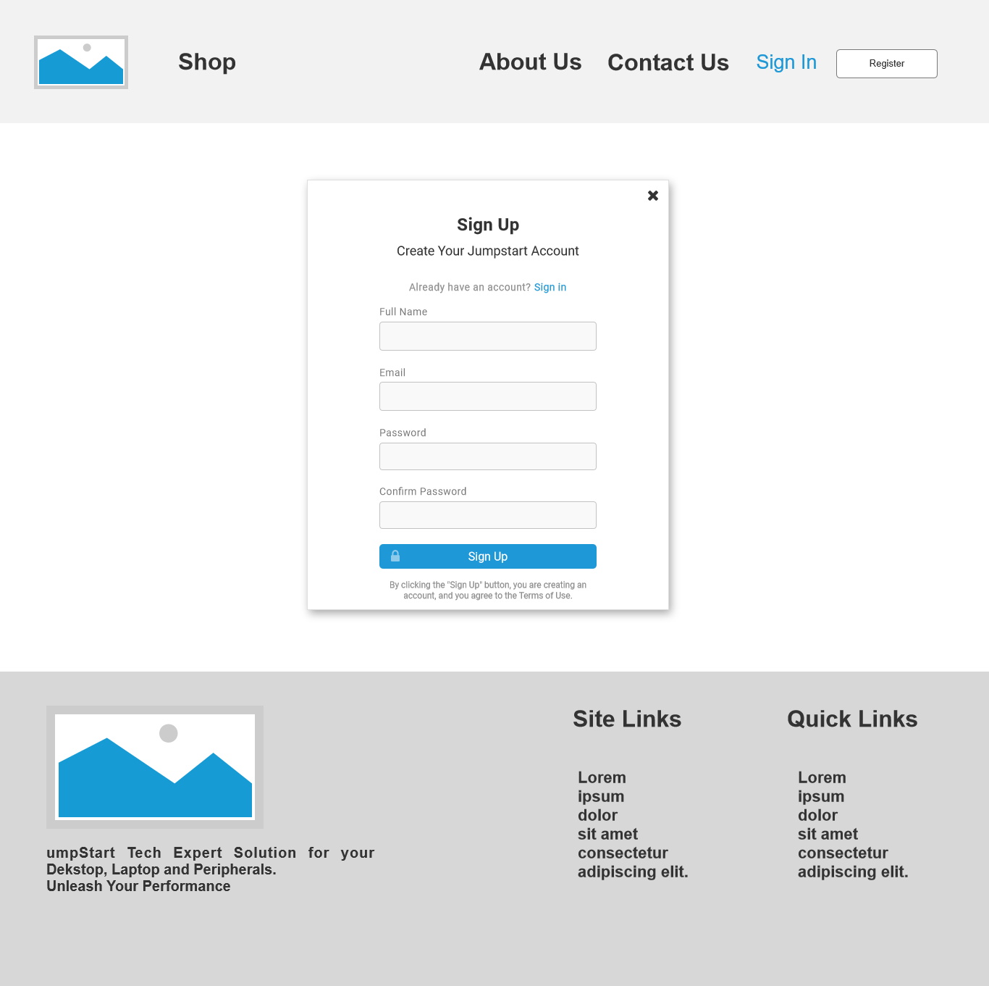

Figure 25 Register Wireframe

**LOGIN**

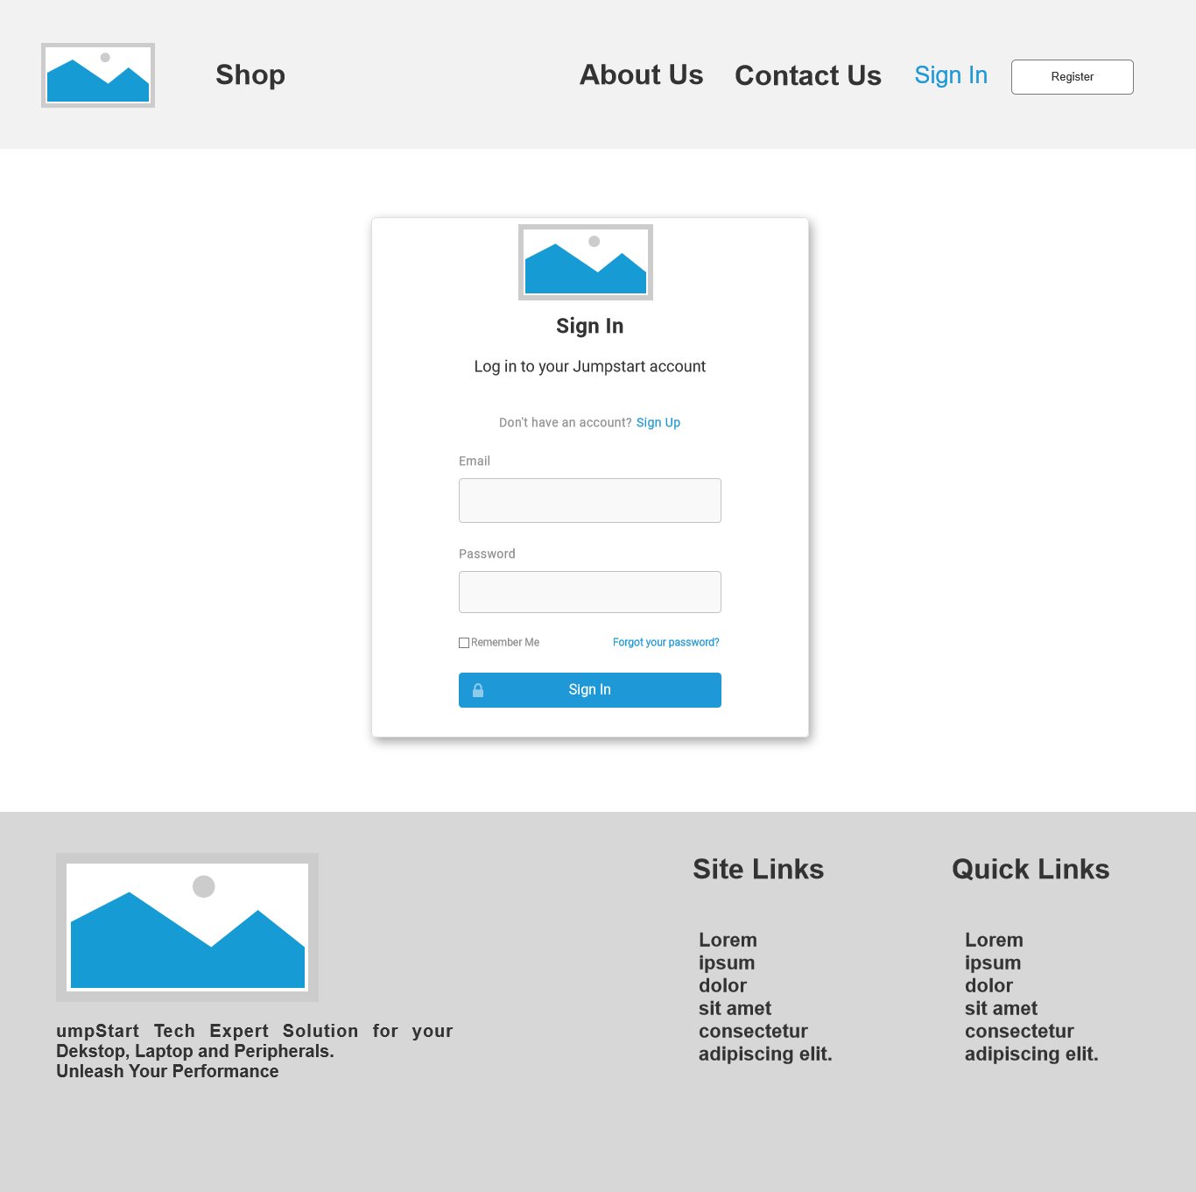

Figure 26 Login Wireframe

**SHOP**

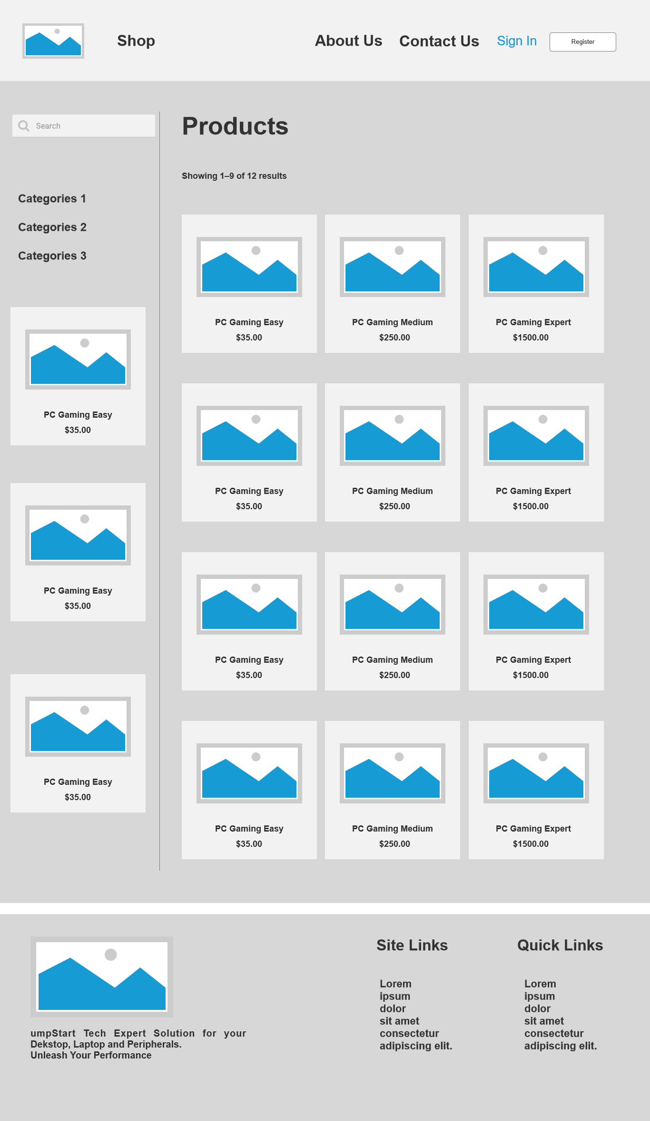

Figure 27 Shop Wireframe

**PRODUCT DETAIL**

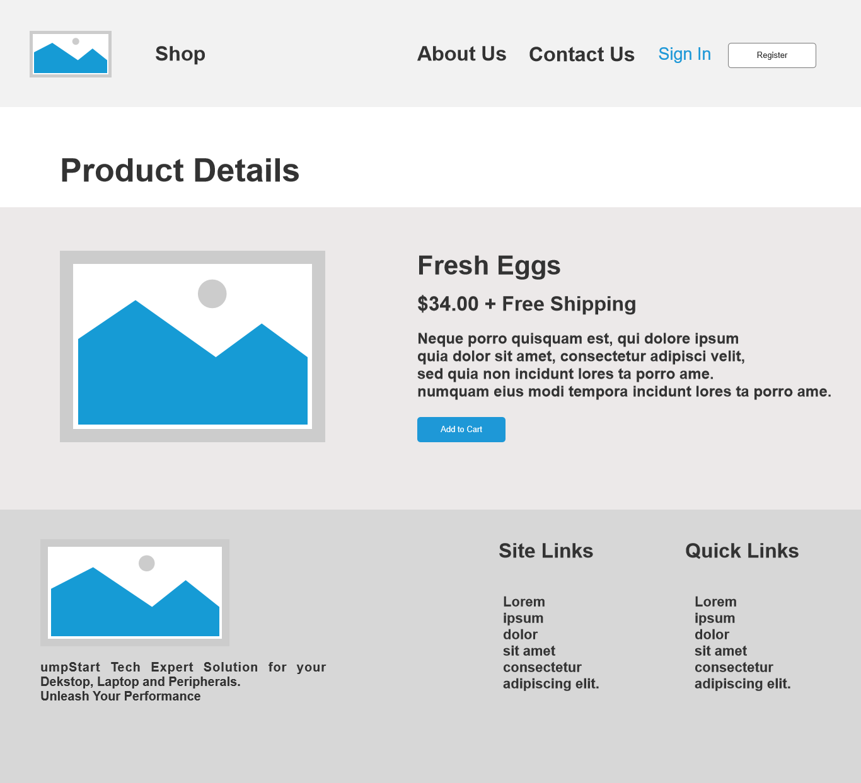

Figure 28 Product Details Wireframe

**CART**

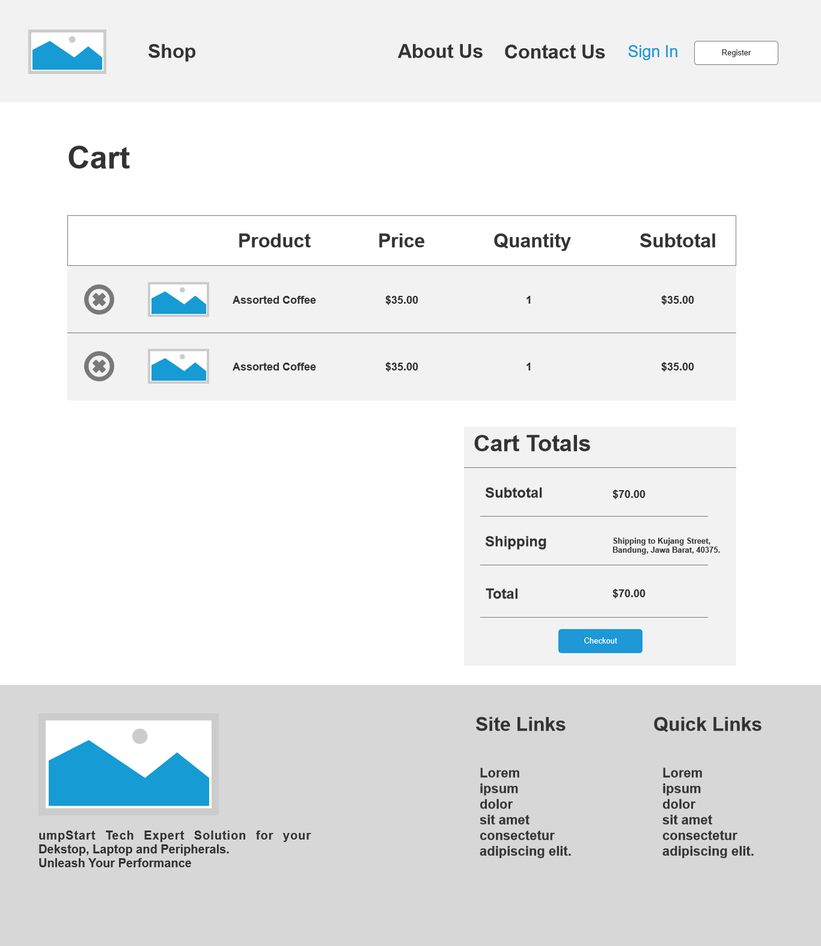

Figure 29 Cart Wireframe

**CHECKOUT**

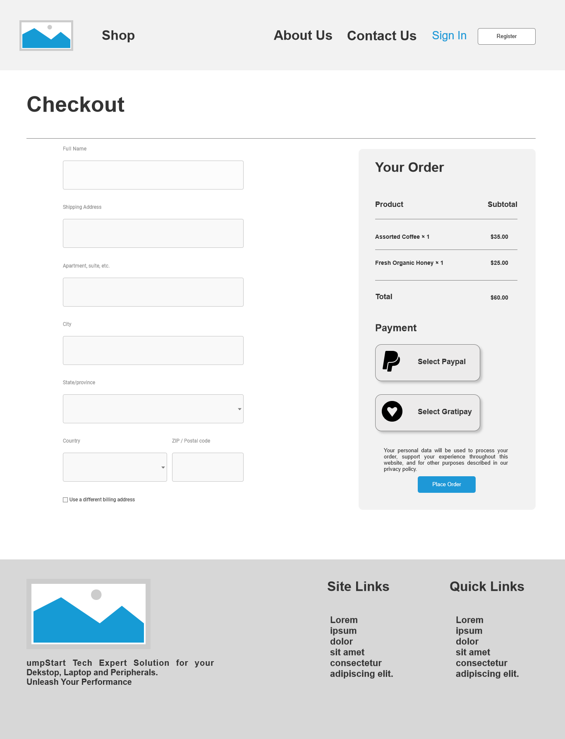

Figure 30 Checkout Wireframe

### Project EERD

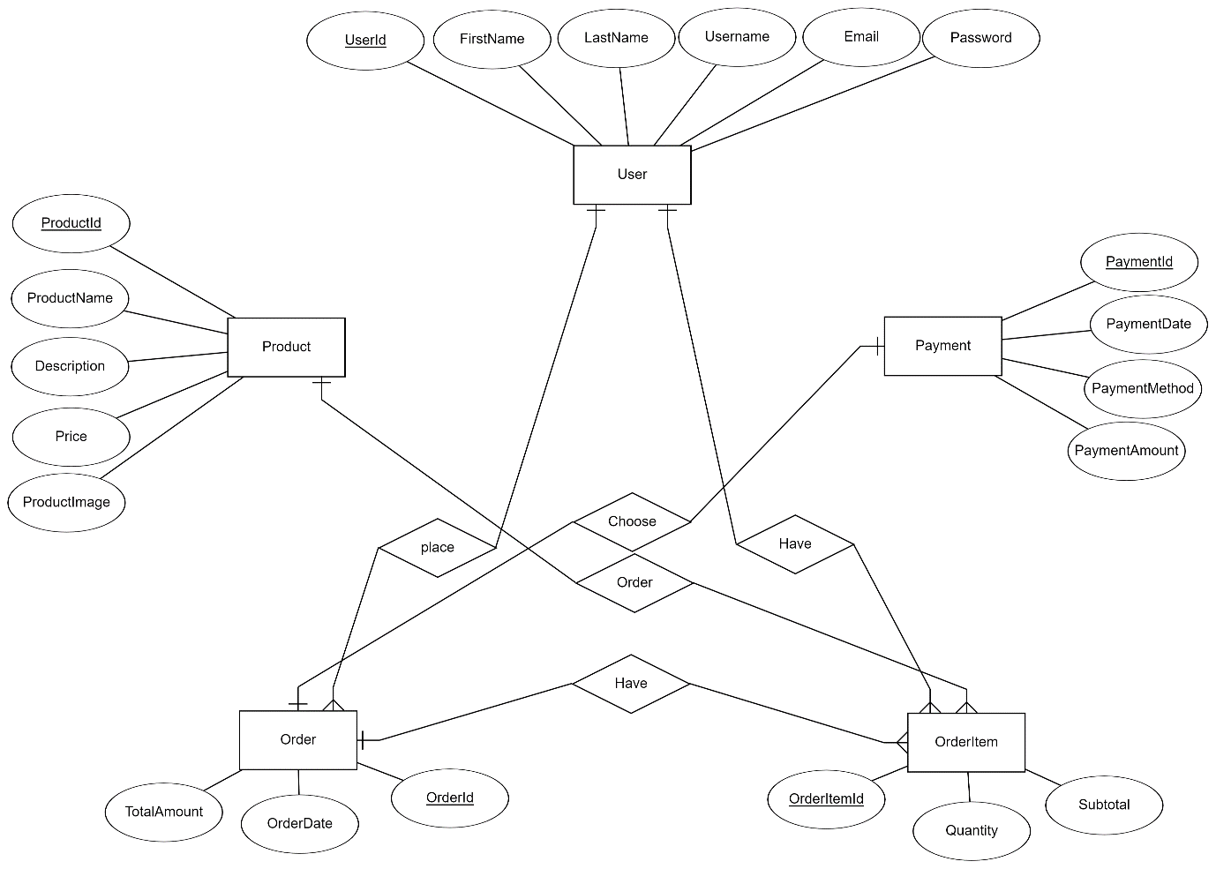

Figure 31 EERD of Jumpstart Website

### Project Relation Schema

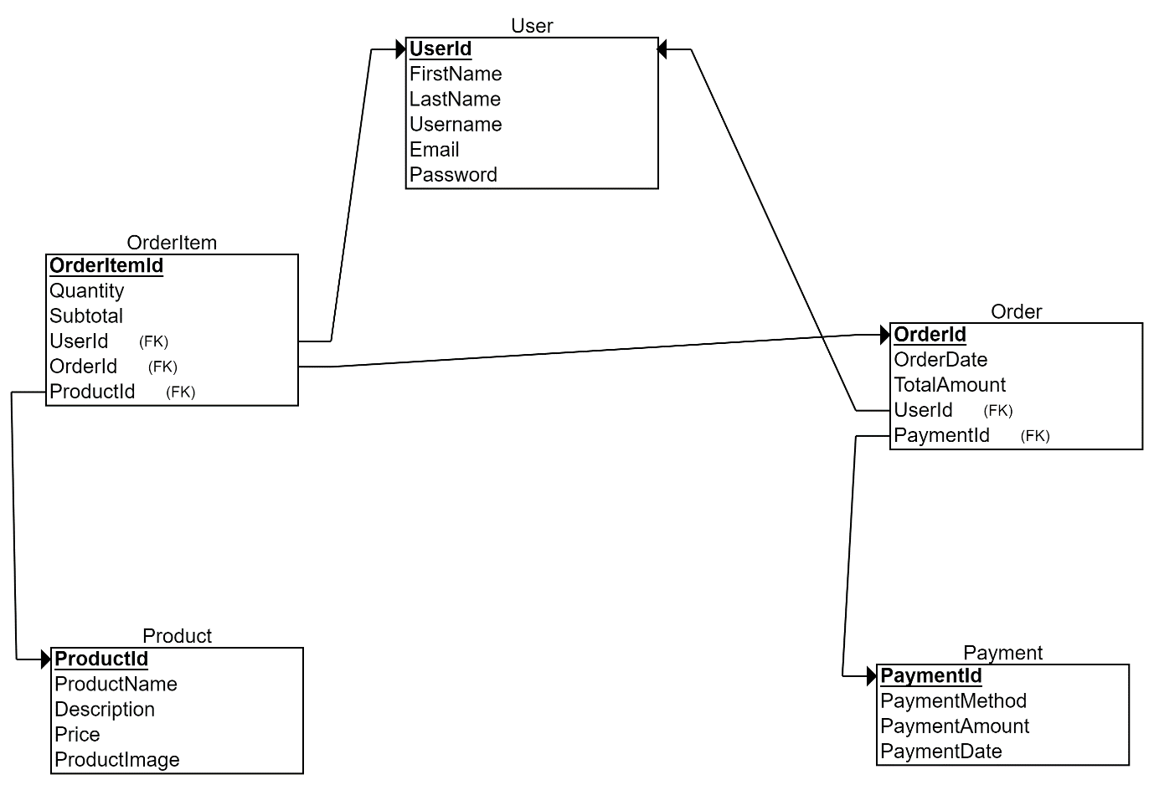

Figure 32 Relation Schema of Jumpstart Website

## Communication with Stakeholders:

**Communication Matrix:** Plan out the following:

Who are the sender and Receiver?

What is the purpose of communication?

What outcome is going to be achieved?

What is the channel of communication?

What is the frequency of communication?

|  |  |  |  |  |  |
| --- | --- | --- | --- | --- | --- |
| Sender | Receiver | Purpose | Outcome | Channel | Frequency |
| Aceadora Project Manager | Chief Operating Manager of Jumpstart | The purpose is to communicate project updates, collect suggestions, and guarantee suitability with Jumpstart's corporate objectives. | Achieve a shared understanding of project progress, challenges, and accomplishments. | Microsoft Teams | Weekly Meetings |
| Aceadora Project Manager | Aceadora Senior Manager | To provide updates on project planning and resource allocation within Aceadora Tech. | Determine the project's progress and the efficient use of internal resources. | Microsoft Teams | Meetings twice a week |
| Aceadora Project Manager | Project Team | To coordinate tasks, assign roles and responsibilities, and facilitate collaboration between team members. | Ensure that everyone in the team is informed, engaged, and working toward the project's objectives. | Microsoft Teams | Meetings three times a week |
| Aceadora Project Manager | Jumpstart Customers | To inform customers about the launch of a new E-commerce website, its features, and the benefits offered. | Increase customer awareness and engagement with the new platform, driving usage and satisfaction. | Microsoft Teams | Once in Project Life |

Table 10 Communication with Stakeholders

## Project Implementation

### Source Code and evidence

**Landing Page**

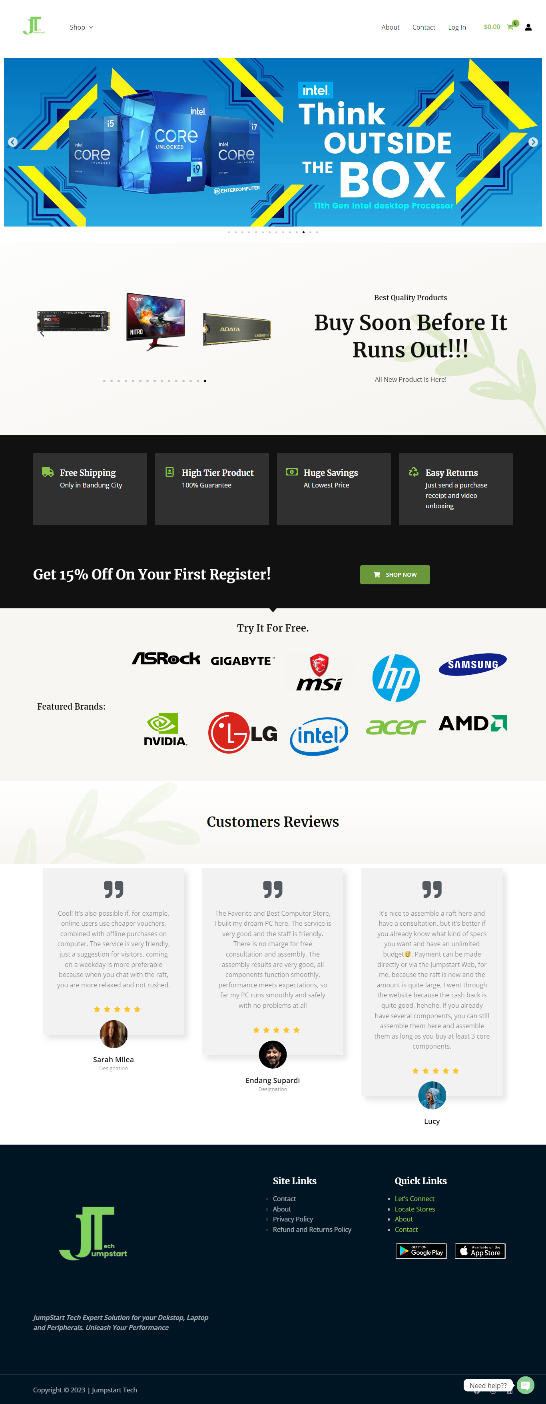

Figure 33 Landing Page

**About Us**

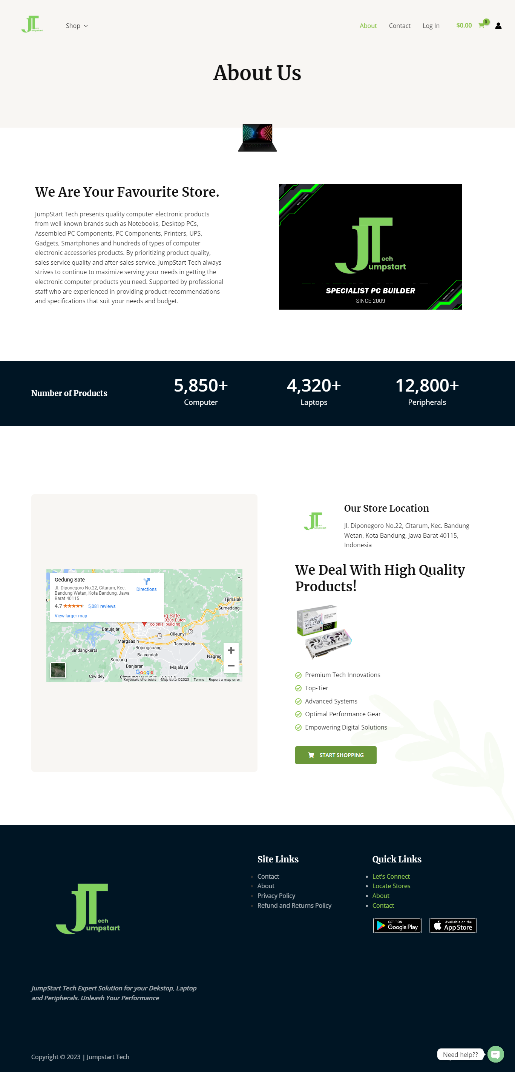

Figure 34 About Us Page

**Contact Us**

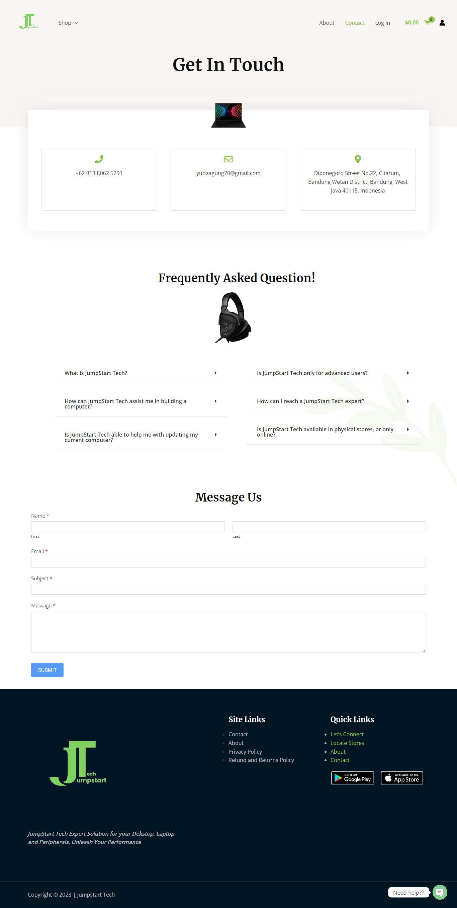

Figure 35 Contact Us Page

**Login Page**

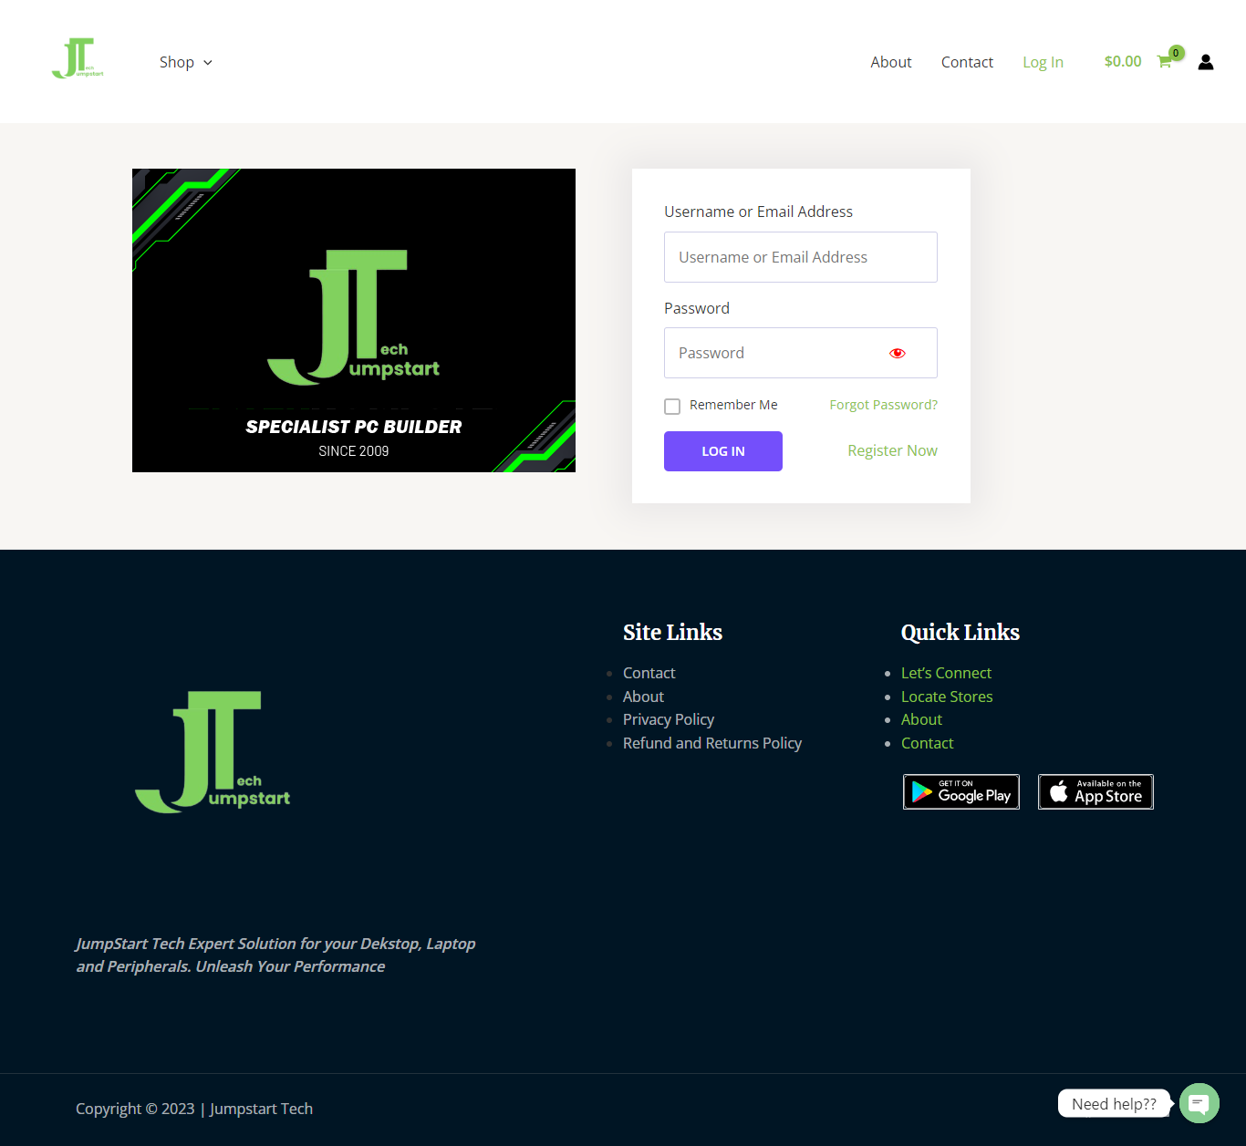

Figure 36 Login Page

**Register Page**

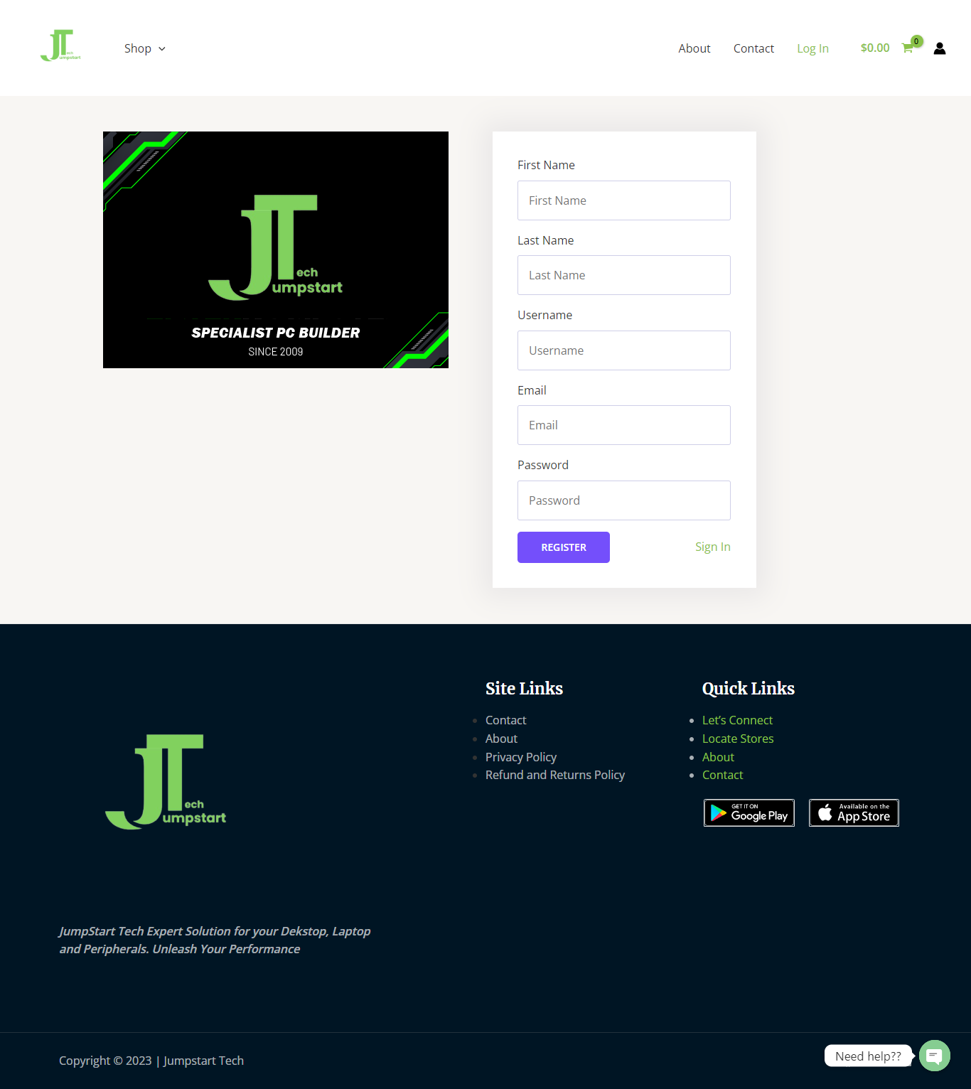

Figure 37 Register Page

**Shop Page**

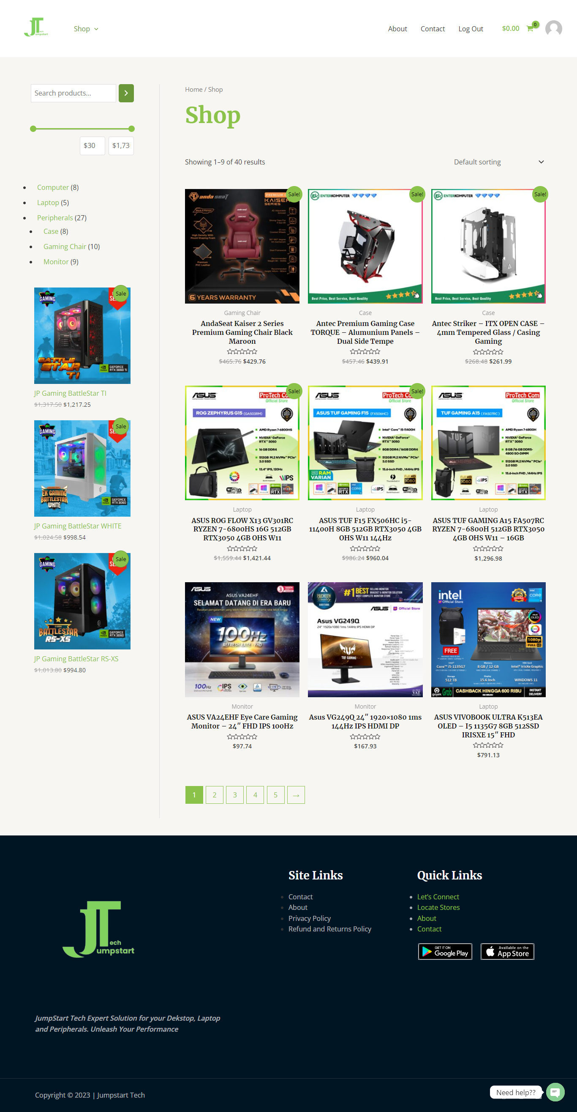

Figure 38 Shopping Page

**Details Product Page**

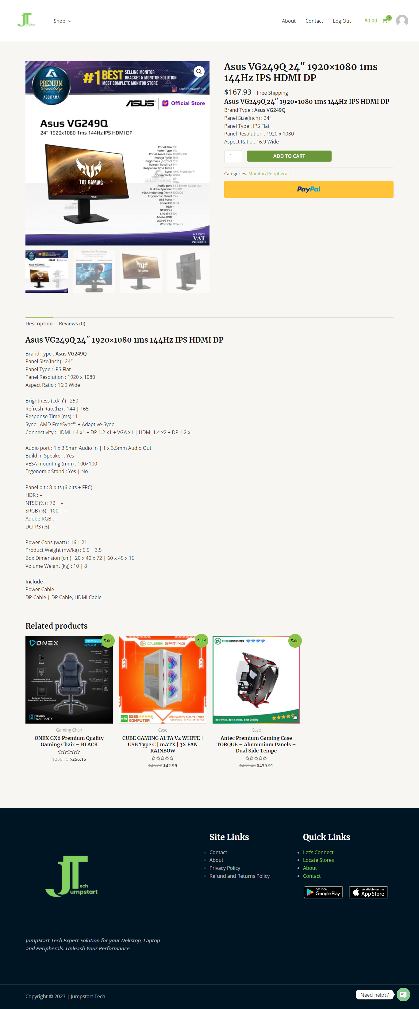

Figure 39 Detail Product Page

**Cart Page**

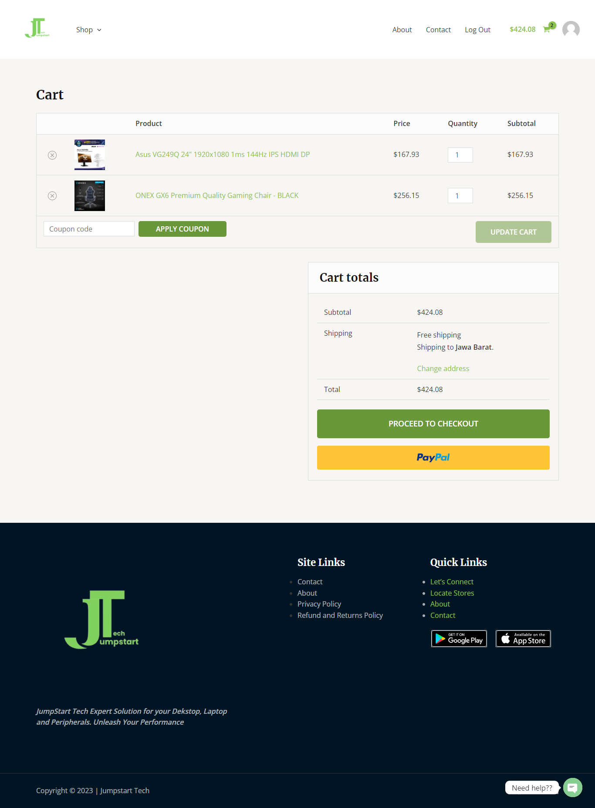

Figure 40 Cart Page

**Checkout Page**

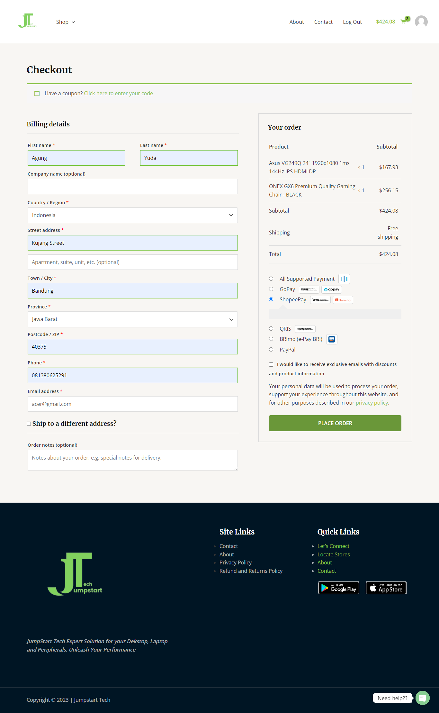

Figure 41 Checkout Page

**Payment Page**

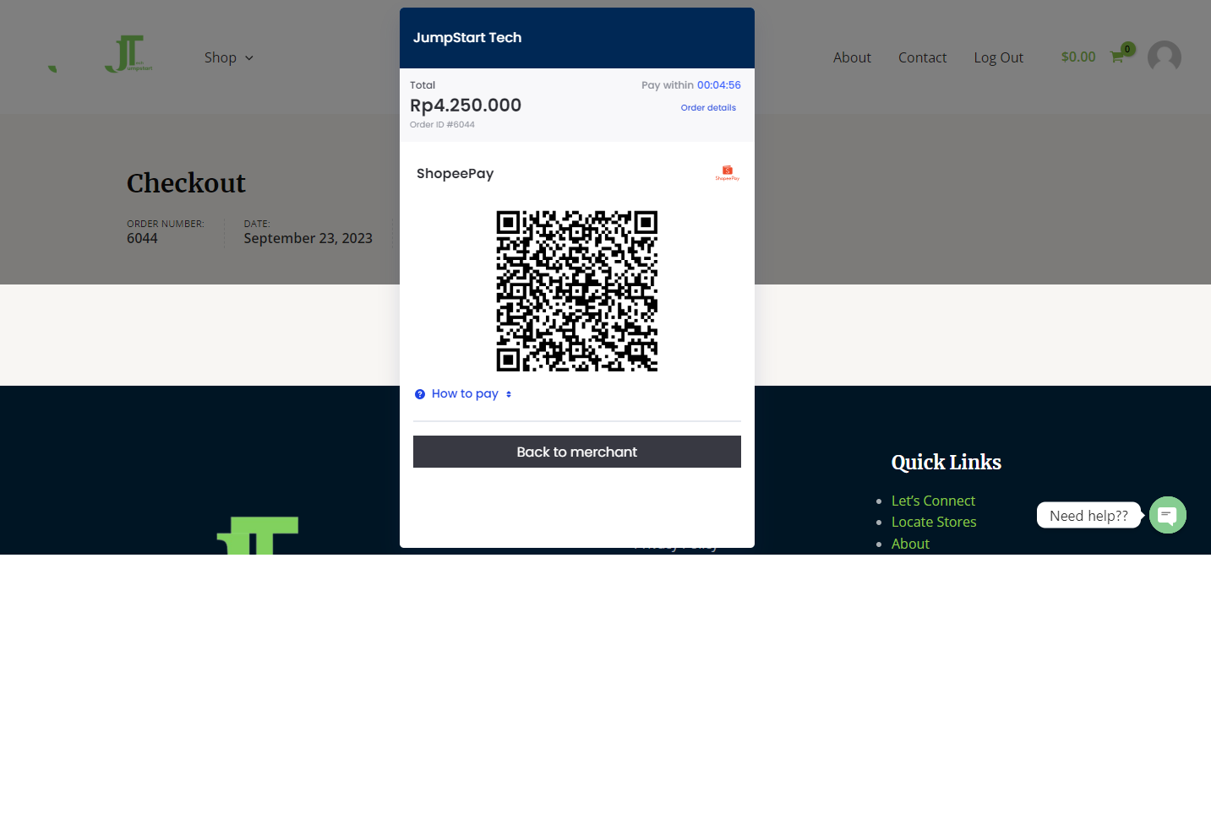

Figure 42 Payment Page

### Post-Implementation Survey

Survey objective: To gain a deeper insight into Jumpstart customers' experience regarding the new Jumpstart business model and their inclination towards customer-centric commerce and online shopping systems.

## Reflection on Research Methods

### Effectiveness and challenges of methods applied

a) Survey:

* Effectiveness: The survey method is often effective in collecting quantitative data from a significant number of respondents. It can provide a broad overview and is often used to measure respondents' opinions, behaviors, or preferences. Surveys can also be used to generalize results to a larger population.
* Challenges: Challenges faced in survey methods include difficulties getting a high response rate from respondents, the need for straightforward questions, and concerns regarding the validity and reliability of the survey tools.

(b) Literature Review:

* Effectiveness: A literature review effectively understands and synthesizes previous research on a particular topic. It helps researchers understand the theoretical foundation and context of their research. A literature review can also identify research gaps that need to be filled.
* Challenges: Challenges in a literature review include determining relevant and credible sources and organizing the scattered literature into a comprehensive understanding. In addition, avoiding selection bias in the selection of literature is also a challenge.

### Alternative methods to overcome the challenges:

**Interview**

* **Collect more in-depth data**: With interviews, you can get more detailed and in-depth information from respondents. You can ask additional questions or ask for clarification if something is unclear. This can provide a better understanding of the topic being researched.
* **Overcoming literacy limitations**: Sometimes, written surveys are challenging to understand for some respondents who have limited literacy. You can explain the questions directly with interviews and help respondents better express their opinions.
* **Build better relationships**: Interviews can help build a better relationship between researchers and respondents. Interacting directly creates a more comfortable atmosphere and makes respondents more open in providing answers.

**Case Study**

* **Deep and Contextual**: Using a case study approach, you will gain a deep understanding of retail revitalization and customer experience improvement in the post-Covid era. Case studies allow us to analyze specific cases of retail companies that have successfully implemented certain strategies. We can learn about the context, challenges, and factors influencing their success in improving customer experience.
* **Relevance to Topic**: Case studies allow us to focus on cases directly related to the research topic. In this case, we can look for case studies of retail companies that have revitalized their businesses and successfully improved customer experience in the post-Covid era. This provides direct relevance to the research objectives.
* **Provide Practical Solutions**: By studying successful cases in retail revitalization and customer experience improvement, it is possible to identify effective strategies, practices, and innovations to adopt. Case studies provide practical insights that can help develop recommendations and concrete actions to improve customer experience in the post-Covid era.

## Conclusion

In the survey results above, most respondents are satisfied with the current Jumpstart e-commerce platform and consider that the product descriptions and images are clear and informative. However, several problems need to be considered, such as product availability, which is still lacking, and a small number of respondents who experienced difficulties on the Jumpstart website, which affected their shopping experience.

Despite this, the majority of respondents are still willing to recommend Jumpstart to their friends or colleagues based on their experience on the e-commerce platform.

We used quantitative research methods with a survey approach and literature review in this research. The survey method allows collecting data from representative respondents about customer experience on the Jumpstart e-commerce platform. The authors used a carefully designed questionnaire to collect respondents' opinions and perceptions regarding the quality of their experience on the platform.

In addition, the author also conducted a comprehensive literature review to gain an in-depth understanding of retail revitalization and customer experience improvement in the post-Covid era. The author investigates articles, books, and other sources that are relevant to the research topic being undertaken. This literature review helps gain theoretical insights and frameworks that can be used to analyze survey data and interpret the findings obtained.

By combining these two methods, the author can understand the customer experience on the Jumpstart e-commerce platform and the effectiveness of the efforts to improve that experience.

So, overall, through quantitative research methods using surveys and literature reviews, the Author identified the strengths and weaknesses of the Jumpstart e-commerce platform regarding customer experience. Then, our efforts to improve the customer experience at Jumpstart have reaped positive results.

## Future research considerations

* **Long-Term Impact of Customer Switching Behavior:** Investigate the long-term consequences of customers switching to competitors due to product availability issues during the pandemic. Understand whether these customers return to Jumpstart once things return to normal or whether they remain loyal to competitors.
* **Improving Product Availability:** Explore strategies to overcome product availability challenges. This could include improving inventory management, optimizing the supply chain, or collaborating with suppliers to ensure consistent product supply.
* **User Experience Optimization:** Go further into user experience elements like website performance and speed. Find ways to enhance the user experience to give customers a more effective and enjoyable online buying experience.
* **Benefit Customer Reviews:** Investigate how customer reviews and product recommendations can have benefits to influence purchasing decisions. Explore ways to encourage more customers to leave reviews and how these reviews impact overall sales.
* **Price and Quality Product Sensitivity:** Conduct a price study to determine whether customers are willing to pay more for improved product quality and availability. Recognize the trade-offs that customers are eager to make.
* **Returns and Exchanges:** Deepen customer satisfaction analysis with returns and exchange policies. Identify trouble spots or areas where the policy can be further improved to improve the overall shopping experience.
* **Customer Service and Problem Resolution:** Examines the role of customer service in resolving issues that impact the shopping experience. Investigate the effectiveness of customer support channels and responsiveness in addressing customer issues.
* **Competitor Analysis:** Conduct a comprehensive analysis of Jumpstart's competitors to identify their strengths and weaknesses. Learn their customer retention strategies and techniques to inform Jumpstart's revitalization efforts.

Bibliography

Birch-Jensen, A., Gremyr, I., Hallencreutz, J., & Rönnbäck. (2020). Use of customer satisfaction measurements to drive improvements. *Total Quality Management and Business Excellence*, *31*(5–6), 569–582. https://doi.org/10.1080/14783363.2018.1436404

Bolton, R. N., McColl-Kennedy, J. R., Cheung, L., Gallan, A., Orsingher, C., Witell, L., & Zaki, M. (2018). Customer experience challenges: bringing together digital, physical and social realms. *Journal of Service Management*, *29*(5), 776–808. https://doi.org/10.1108/JOSM-04-2018-0113

Borrego, M., Douglas, E. P., & Amelink, C. T. (2009). *Quantitative, Qualitative, and Mixed Research Methods in Engineering Education*.

Ciotti, M., Ciccozzi, M., Terrinoni, A., Jiang, W. C., Wang, C. Bin, & Bernardini, S. (2020). The COVID-19 pandemic. In *Critical Reviews in Clinical Laboratory Sciences* (pp. 365–388). Taylor and Francis Ltd. https://doi.org/10.1080/10408363.2020.1783198

Creswell, J. W. (2009). *Research design : qualitative, quantitative, and mixed methods approaches*. Sage.

Creswell, J. W., & David Creswell, J. (2018). *Research Design: Qualitative, Quantitative, and Mixed Methods Approaches*.

Donthu, N., & Gustafsson, A. (2020). Effects of COVID-19 on business and research. In *Journal of Business Research* (Vol. 117, pp. 284–289). Elsevier Inc. https://doi.org/10.1016/j.jbusres.2020.06.008

Flick, U. (2015). *Uwe Flick - Introducing Research Methodology_ A Beginner′s Guide to Doing a Research Project-SAGE Publications Ltd (2015)*.

Goulding, C. (2005). Grounded theory, ethnography and phenomenology: A comparative analysis of three qualitative strategies for marketing research. *European Journal of Marketing*, *39*(3-4 SPEC. ISS.), 294–308. https://doi.org/10.1108/03090560510581782

Jacks, T. (2021). Research on Remote Work in the Era of COVID-19. In *Journal of Global Information Technology Management* (Vol. 24, Issue 2, pp. 93–97). Bellwether Publishing, Ltd. https://doi.org/10.1080/1097198X.2021.1914500

Meyer, C., & Schwager, A. (2007). *Understanding Customer Experience*. www.gethuman.com

Saunders, M., Lewis, P., Thornhill, A., Lewis, S. •, & Thornhill, •. (2009). *Research methods for business students fifth edition*. www.pearsoned.co.uk

Sigala, M. (2020). Tourism and COVID-19: Impacts and implications for advancing and resetting industry and research. *Journal of Business Research*, *117*, 312–321. https://doi.org/10.1016/j.jbusres.2020.06.015

Verhoef, P. C., Broekhuizen, T., Bart, Y., Bhattacharya, A., Qi Dong, J., Fabian, N., & Haenlein, M. (2021). Digital transformation: A multidisciplinary reflection and research agenda. *Journal of Business Research*, *122*, 889–901. https://doi.org/10.1016/j.jbusres.2019.09.022